 

**FoodConnect- To supply left over food to poor**



**Project Overview**

**Food Connect** is a platform built on Salesforce that streamlines the process of gathering surplus food from donors—such as restaurants, events, and households—and delivering it to underserved communities. By utilizing Salesforce’s robust CRM features, the system effectively manages donor information, monitors food availability, and coordinates delivery logistics. It also automates key processes to ensure prompt communication and smooth supply chain operations.  
The platform promotes sustainability by reducing food waste and supports social welfare by ensuring that excess food reaches those who need it most. Its scalable design allows for easy expansion to serve broader geographic areas and a growing network of donors and recipients.

## Table of Contents

1. Introduction
2. Project Objectives
3. Key Features
4. Salesforce Developer Setup
5. System Architecture
6. Screenshots of Output
7. Conclusion

## **Introduction**

Food Connect is built to address food waste while helping people in need. The project uses Salesforce as a backbone for its donor management, food inventory tracking, and delivery coordination. By incorporating the full power of Salesforce’s CRM, automation, and analytics capabilities, this platform enables seamless collaboration between food donors, volunteers, and distribution networks

## **Project Objectives**

* + **Distribute leftover food** efficiently to charities and shelters.
  + **Automate workflows** for notifications, pickups, and deliveries.
  + **Track inventory and supply chain** in real-time.
  + **Improve community outreach** and reporting.

## **Key Features**

* + **Food Pickup and Distribution Tracking:** Automate requests for food pickup and ensure delivery to shelters.
  + **Inventory Management:** Monitor food availability in real-time, ensuring efficient allocation based on demand.
  + **Reporting and Analytics:** Create reports and dashboards on food distribution, donor contributions, and recipients.
  + **Mobile Access:** Allow volunteers and coordinators to access the platform on mobile devices using Salesforce Mobile.

1. **Salesforce Developer Setup and Workflow**

# Creating Developer Account

Creating a developer org in salesforce.

* 1. Go to <https://developer.salesforce.com/signup>
  2. On the sign-up form, enter the following details:

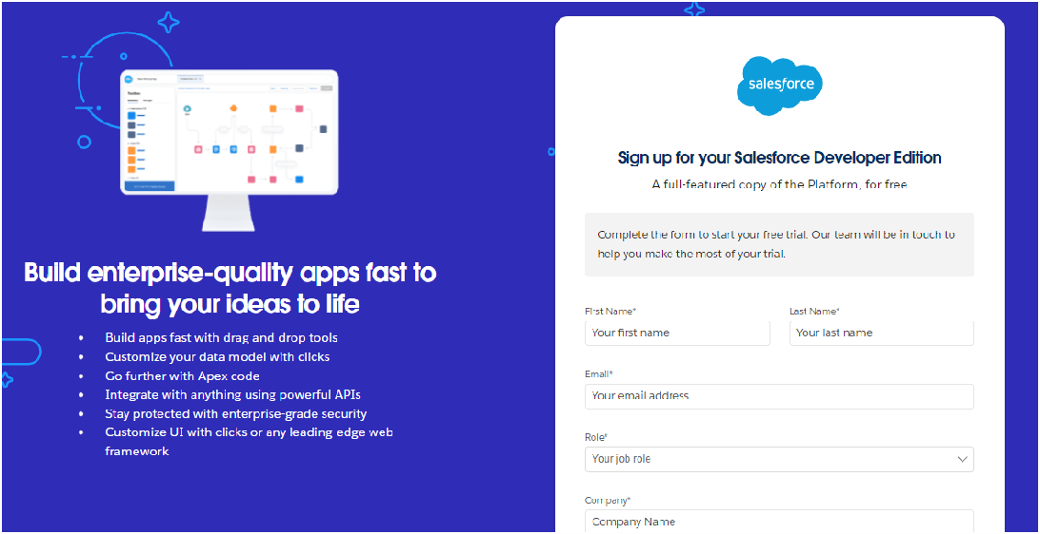

* + 1. First name & Last name
    2. Email
    3. Role: Developer
    4. Company: College or Company Name
    5. County: India
    6. Postal Code: pin code
    7. Username: should be a combination of your name and company

1. **System Architecture**

# **Account Activation**

* 1. Go to the inbox of the email that you used while signing up. Click on the verify account to activate your account. The email may take 5-10mins.

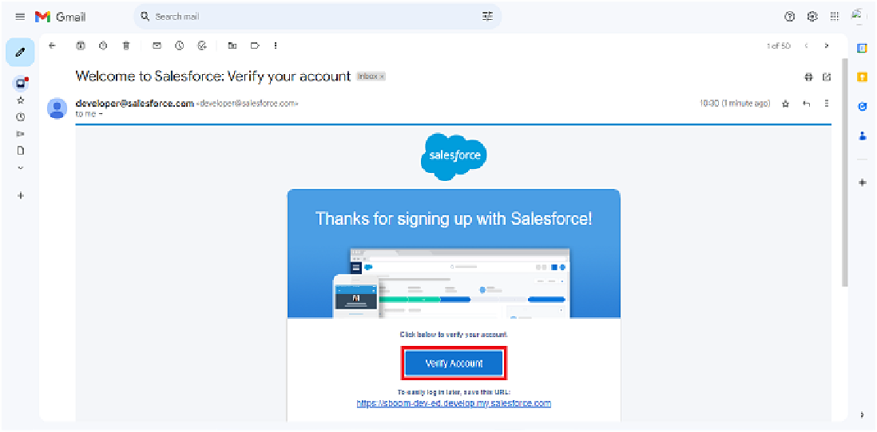

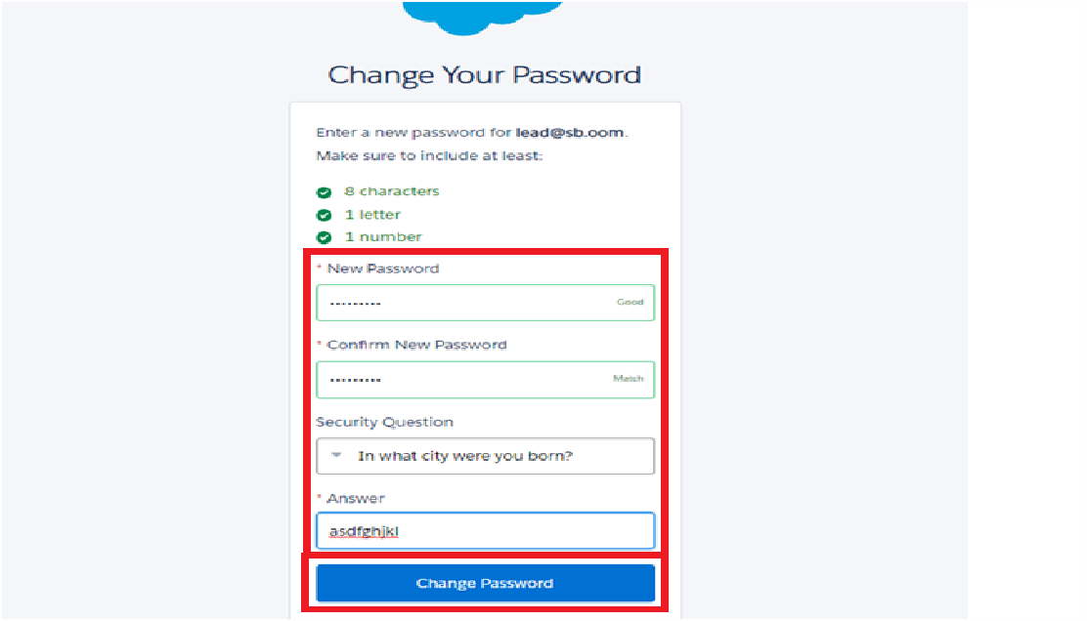

1. Click Verify Account
2. Give a password and answer a security question and click on change password.
3. Give a password and answer a security question and click on change password.
4. Then you will redirect to your salesforce setup page.

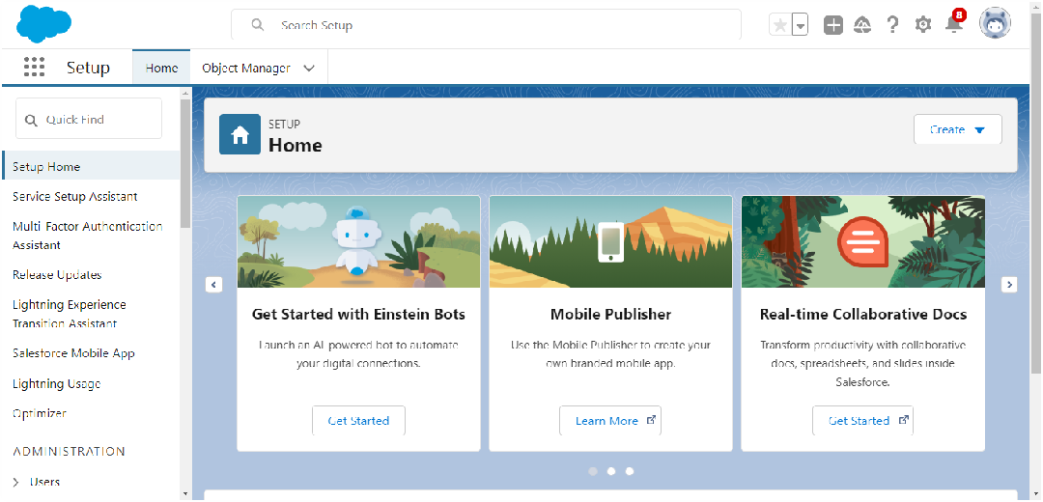

# Creating Objects

To Navigate to Setup page:

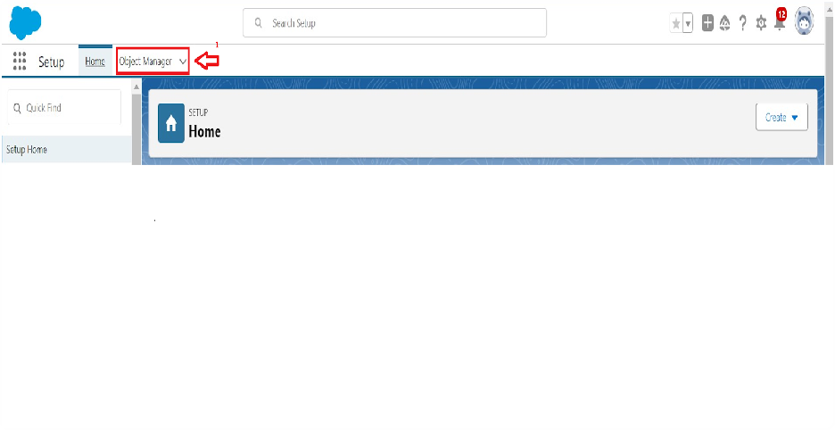

To create an object:

* 1. From the setup page > Click on Object Manager > Click on Create > Click on Custom Object.

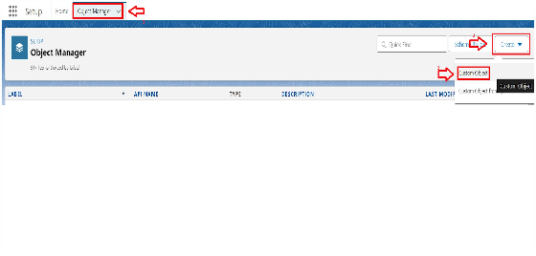

1. On Custom object defining page:
2. Enter the label name, plural label name, click on Allow reports, Allow search.

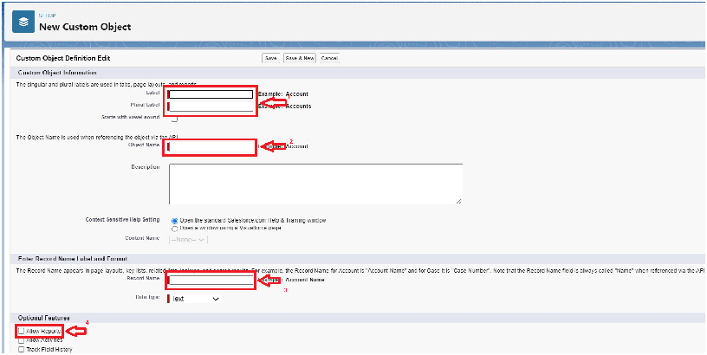

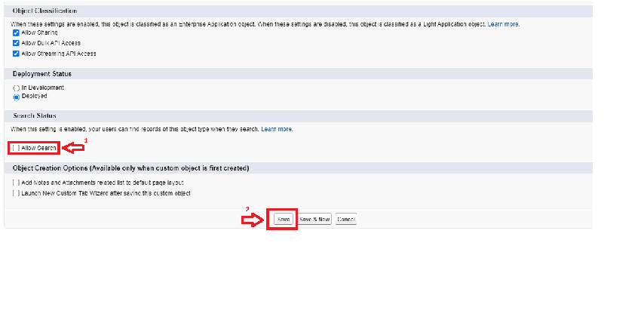

1. Click on Save.

here we create 4 objects in the projects that venue object, drop-off point object,

task object, volunteer object, execution details object. As the same way as above mention in the screenshots you have to follow the same process for every object that you made.

# Creating a Custom Tab

To create a Tab:(Venue)

* 1. 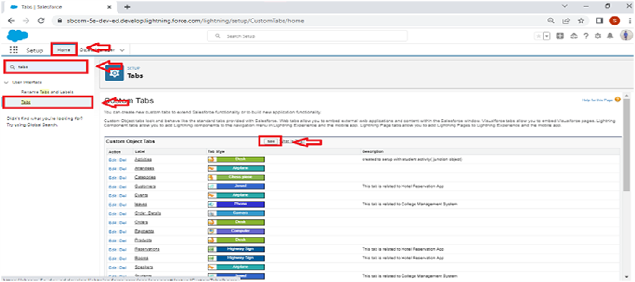Go to setup page >> type Tabs in Quick Find bar >> click on tabs >> New (under custom object tab)

1. Select Object (Venue) >> Select the tab style >> Next (Add to profiles page) keep it as default >> Next (Add to Custom App) uncheck the include tab.
2. Make sure that the Append tab to users' existing personal customizations is checked.
3. Click save

# Create a Lightning App

### To create a lightning app page:

* 1. Go to setup page >> search “app manager” in quick find >> select “app manager”

>> click on new lightning App.

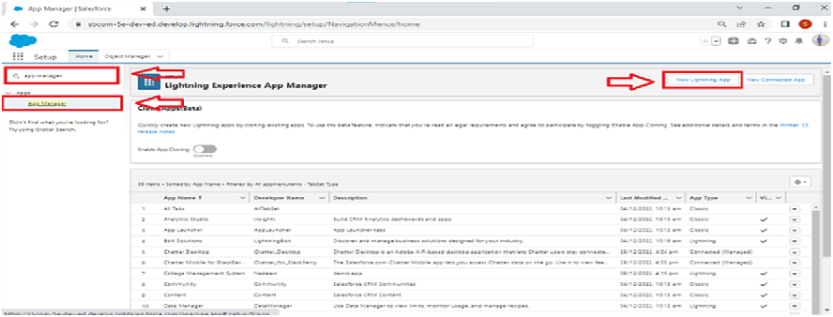

* 1. Fill the app name in app details and branding as follow App Name: FoodConnect

Developer Name: This will auto be populated

Image: optional (if you want to give any image you can otherwise not mandatory) Primary color hex value: keep this default.

3. Then click Next >> (App option page) Set Navigation Style as Standard Navigation >> Next

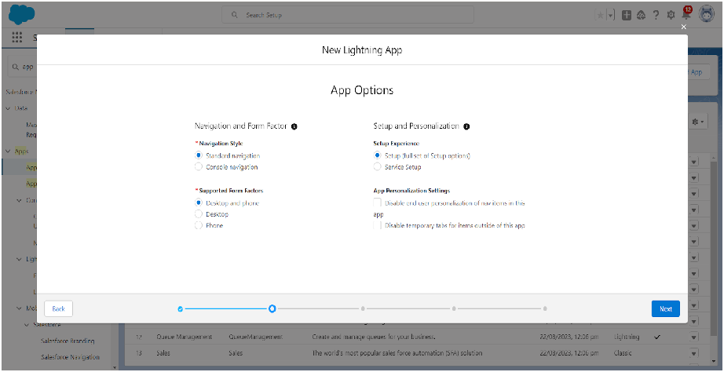

* 1. (Utility Items) keep it as default >> Next.
  2. To Add Navigation Items:

Search for the item in the (Home, Venue, Drop-Off Point, Task, Volunteer, Execution Details, Reports) from the search bar and move it using the arrow button >> Next

>> Next.

* 1. To Add User Profiles:

Search profiles (System administrator) in the search bar >> click on the arrow button >> save & finish.

**Here I am adding my output of creating lighting app:**

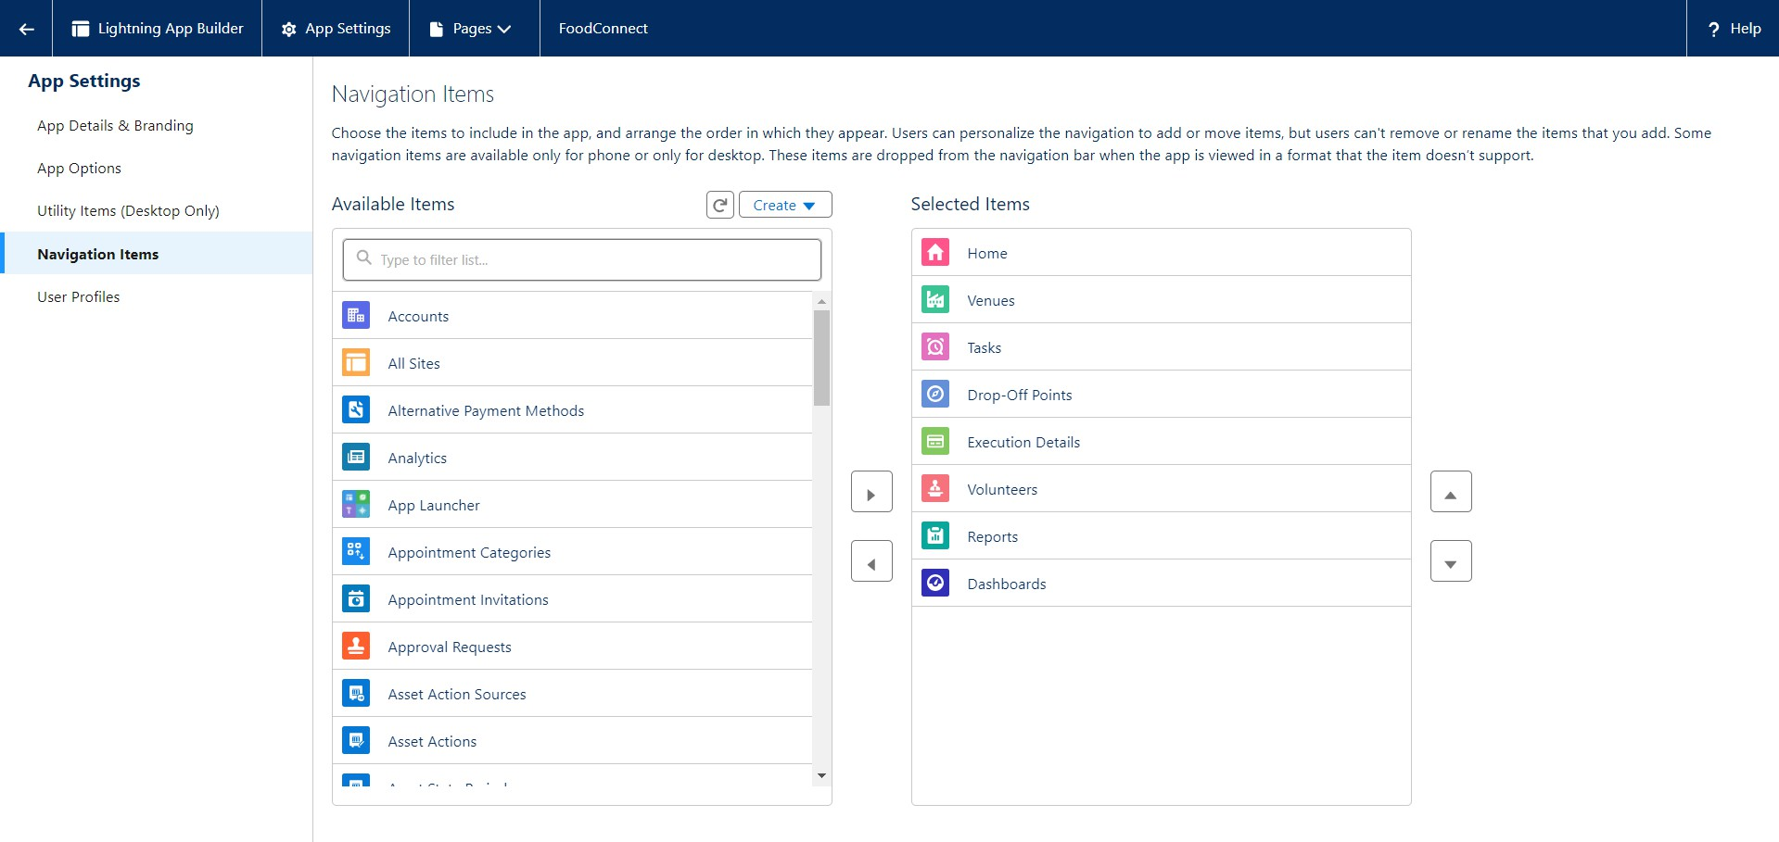

# Creation of Relationship fields in objects

### Creation of Lookup Relationship Field on Volunteer Object:

* 1. Go to setup >> click on Object Manager >> type object name (Volunteer) in the search bar >> click on the object.

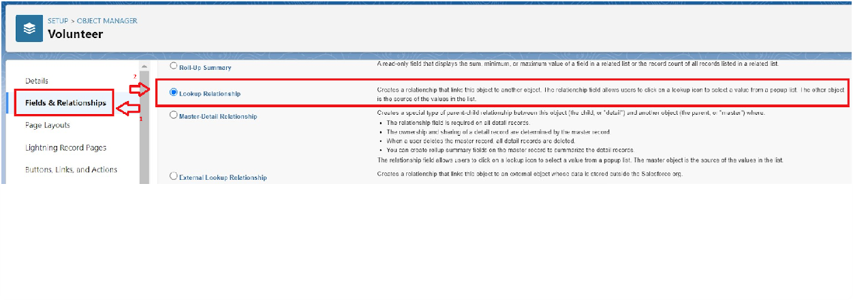

* 1. Now click on “Fields & Relationships” >> New
  2. Select Master Detail relationship
  3. Select the related object “Drop-Off point” and click next.

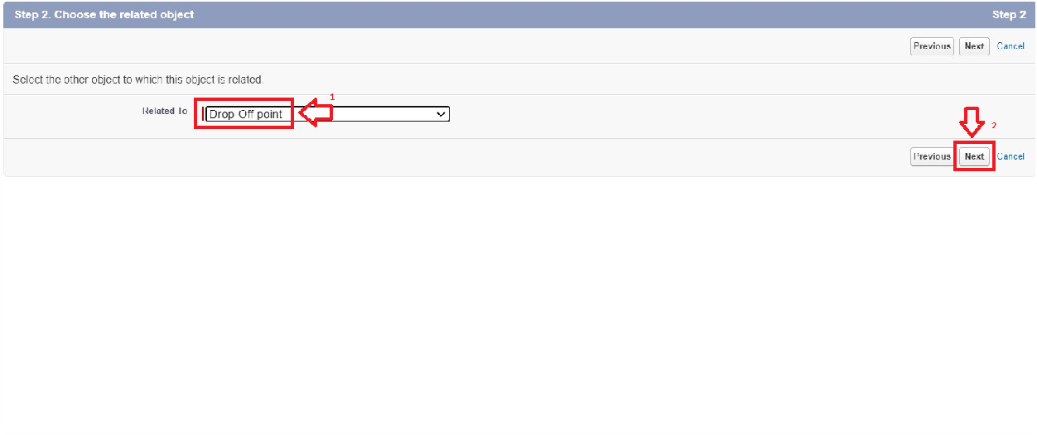

* 1. Field Name: Drop-Off point
  2. Field label: Auto generated
  3. Next >> Next >> Save.

just like that I crated all the relationship as the same way it little bit different in the Moden relationship and the lookup relationship fields.

# Creation of fields for the Venue object

1. Go to setup>> click on Object Manager >> type object name (Venue) in search bar

>> click on the object.

1. Now click on “Fields & Relationships” >> New
2. Select Data type as a “Email” and Click on Next
3. Fill the Above as following:
   * + Field Label: Contact Email
     + Field Name: Contact Email
     + Click on required check box
     + Click on Next >> Next >> Save and new.

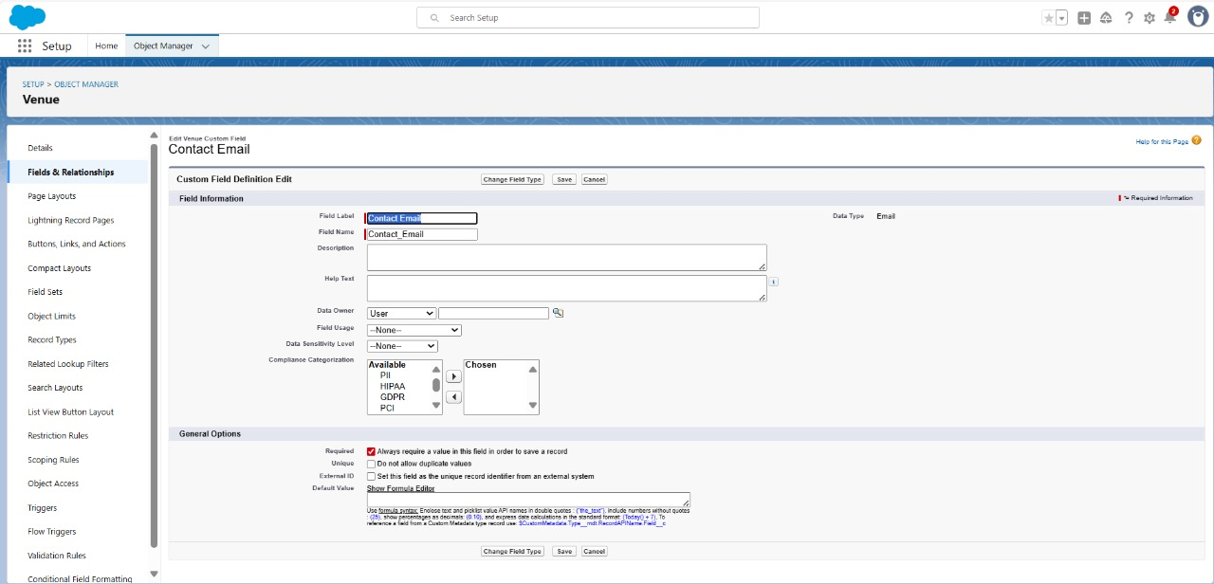

### To create contact phone in venue object:

1. Go to setup >> click on Object Manager >> type object name (Venue) in search bar

>> click on the object.

1. Now click on “Fields & Relationships” >> New
2. Select Data type as a “Phone” and Click on Next
3. Fill the Above as following:
   * + Field Label: Contact Phone
     + Field Name: Contact Phone
     + Click on required check box
     + Click on Next >> Next >> Save and new.

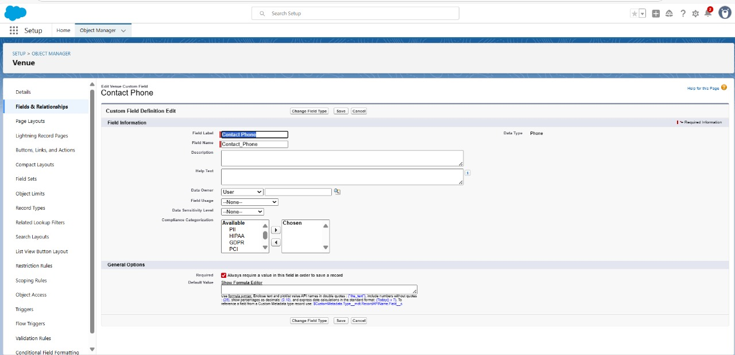

### To create location in venue object:

1. Go to setup >> click on Object Manager >> type object name (Venue) in search bar

>>click on the object.

1. Now click on “Fields & Relationships” >> New
2. Select Data type as a “Geolocation” and Click on Next
3. Fill the Above as following:
   * + Field Label: Location
     + Decimal Places: 4
     + Field Name: Location
     + Description: Enter the Geolocation of your Venue
     + Click on Next >> Next >> Save and new.

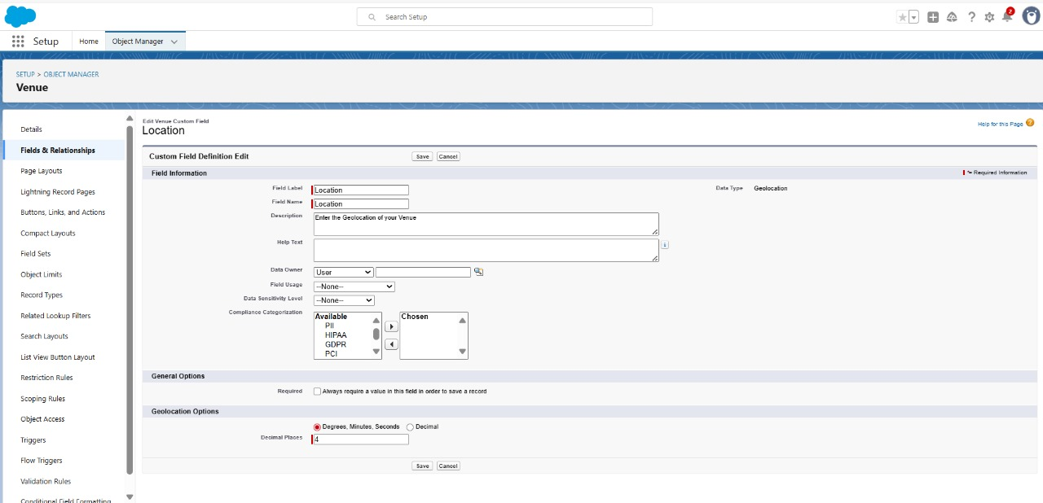

To create Venue Location fields in an object:

1. Go to setup >> click on Object Manager >> type object name (Venue) in search bar

>> click on the object.

1. Now click on “Fields & Relationships” >> New
2. Select Data type as a “Long Text Area” and Click on Next
3. Fill the Above as following:
   * + Field Label: Venue Location
     + Field Name: Venue Location
     + Click on Next >> Next >> Save and new.

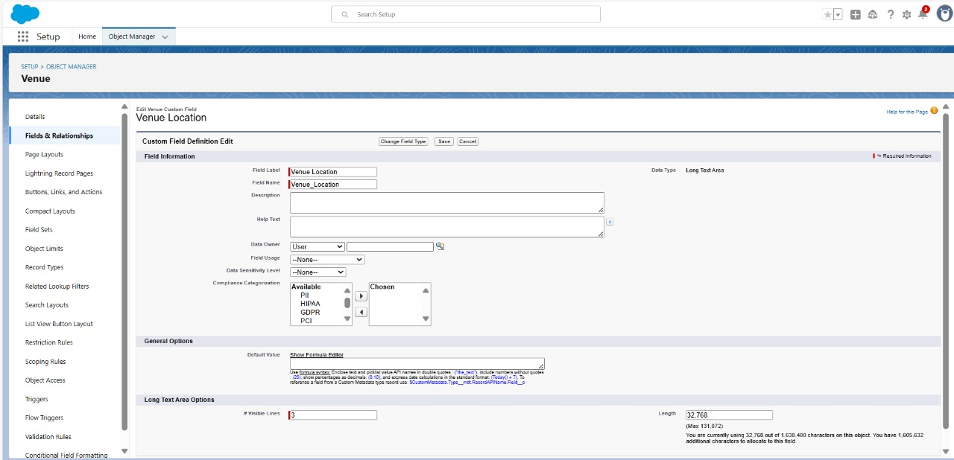

# Creation of fields for the Drop-Off point object

Go to setup >> click on Object Manager >> type object name (Drop-Off point) in search bar

>> click on the object.

1. Now click on “Fields & Relationships” >> New
2. Select Data type as a “Geolocation” and Click on Next
3. Fill the Above as following:
   * + Field Label: Location 2
     + Field Name: gets auto generated
     + Description: Enter the Geolocation of the Drop off Point
     + Geolocation Options: select Decimal
     + Decimal Places: 4
     + Click on Next >> Next >> Save and new.

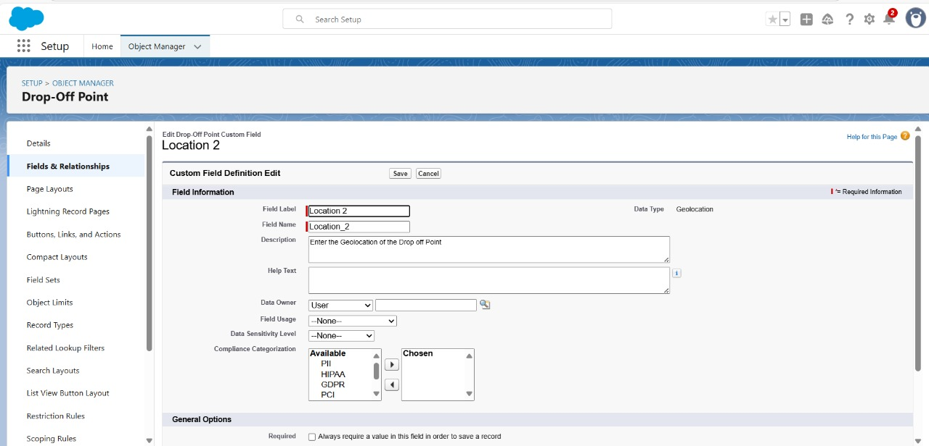

To create distance calculation in Drop-Off point object:

1. Go to setup >> click on Object Manager >> type object name(Drop-Off point) in search bar >> click on the object.
2. Now click on “Fields & Relationships” >> New
3. Select Data type as a “Formula” and Click on Next
4. Fill the Above as following:
   * Field Label: distance calculation
   * Field Name: distance calculation
   * Formula Return Type: Number
   * Formula Options: DISTANCE (Location_2 c , Venue r.Location c , 'km')
   * Click on Next >> Next >> Save and new.

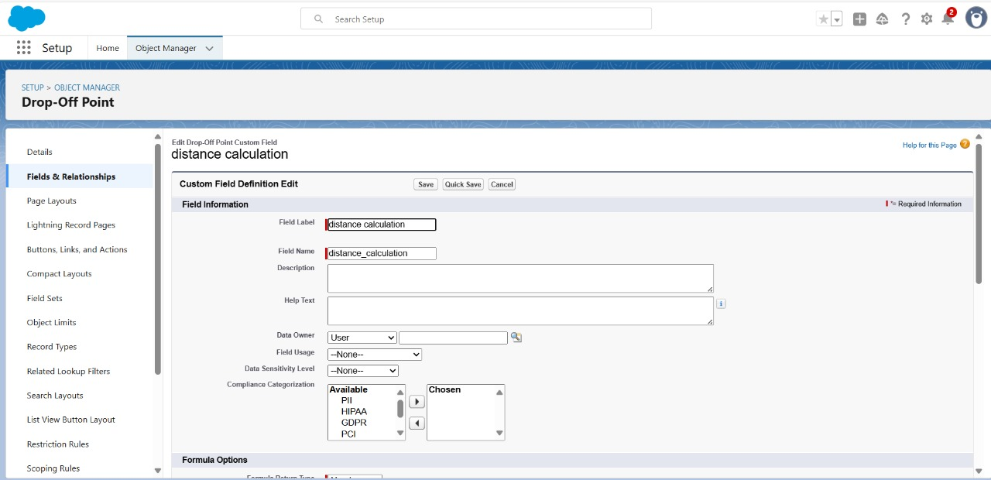

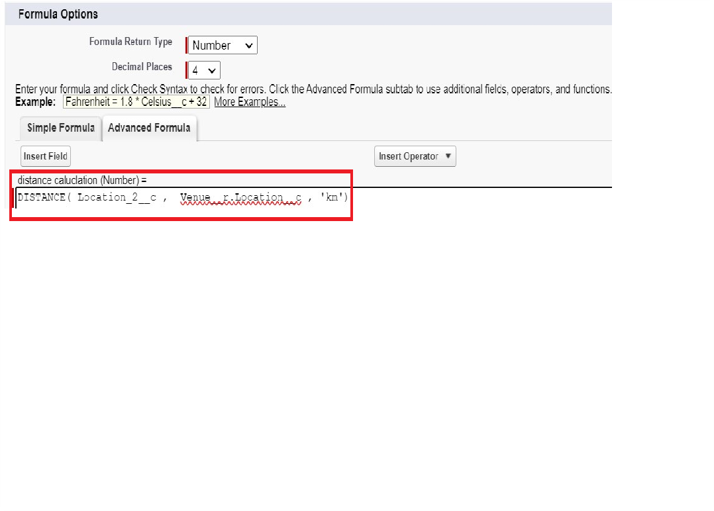

To create State in Drop-Off point object:

1. Go to setup >> click on Object Manager >> type object name(Drop-Off point) in search bar >> click on the object.
2. Now click on “Fields & Relationships” >> New
3. Select Data type as a “Picklist” and Click on Next
4. Fill the Above as following:
   * Field Label : State
   * Field Name : State

Enter values, with each value separated by a new line :

Andhra Pradesh

Arunachal Pradesh Assam

Bihar Chhattisgarh Goa

Gujarat Haryana

Himachal Pradesh Jharkhand Karnataka

Kerala Maharashtra Madhya Pradesh Manipur Meghalaya Mizoram Nagaland Odisha

Punjab

Rajasthan Sikkim Tamil Nadu Tripura Telangana

Uttar Pradesh Uttarakhand West Bengal

Andaman & Nicobar (UT)

Chandigarh (UT)

Dadra & Nagar Haveli and Daman & Diu (UT) Delhi [National Capital Territory (NCT)] Jammu & Kashmir (UT)

Ladakh (UT) Lakshadweep (UT) Puducherry (UT)

* + Click on required check box
  + Click on Next >> Next >> Save and new.

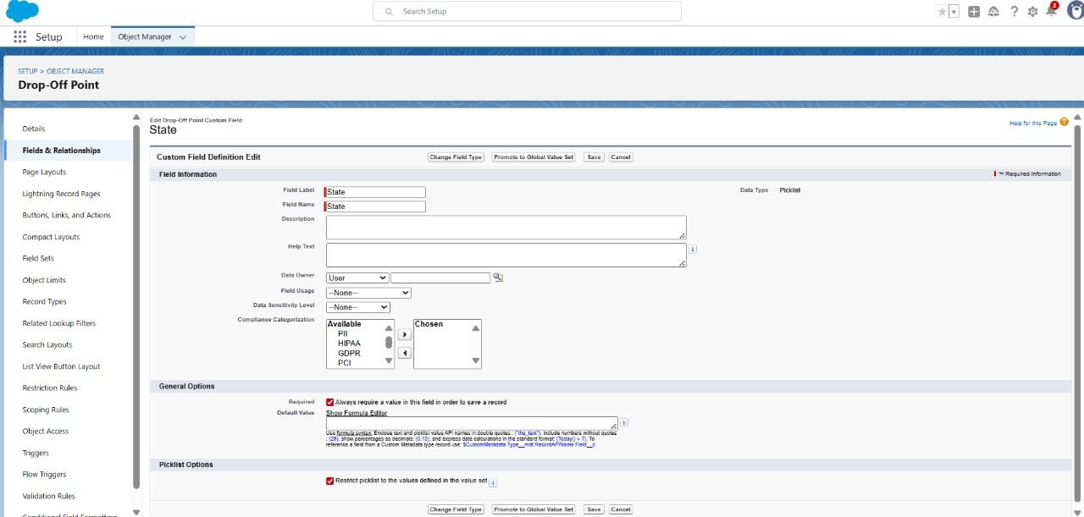

To create Distance in Drop-Off point object:

1. Go to setup >> click on Object Manager >> type object name(Drop-Off point) in search bar >> click on the object.
2. Now click on “Fields & Relationships” >> New
3. Select Data type as a “Number” and Click on Next
4. Fill the Above as following:
   * Field Label : Distance
   * Field Name : Distance
   * Length : 14
   * Decimal Places : 4
   * Click on required check box
   * Click on Next >> Next >> Save and new.

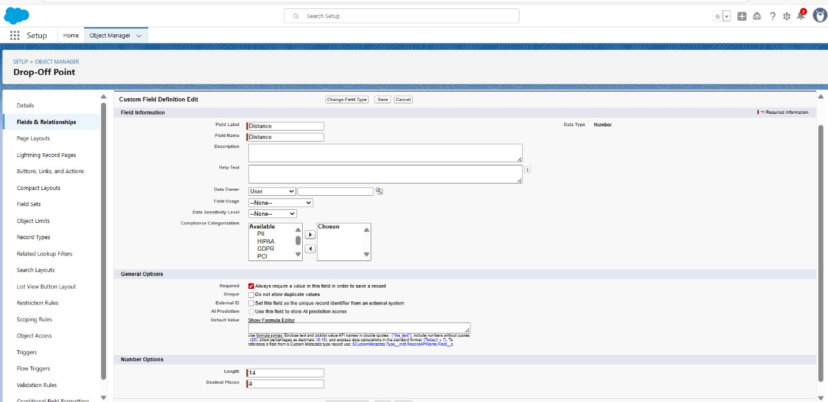

# Creation of fields for the Task object

Go to setup>> click on Object Manager >> type object name (Task) in search bar >> click on the object.

1. Now click on “Fields & Relationships” >> New
2. Select Data type as a “Auto Number” and Click on Next
3. Fill the Above as following:
   * Field Label: Task ID
   * Display Format: TASK-{0}
   * Starting Number: 1
   * Field Name: gets auto generated
   * Click on required check box
   * Click on Next >> Next >> Save and new.

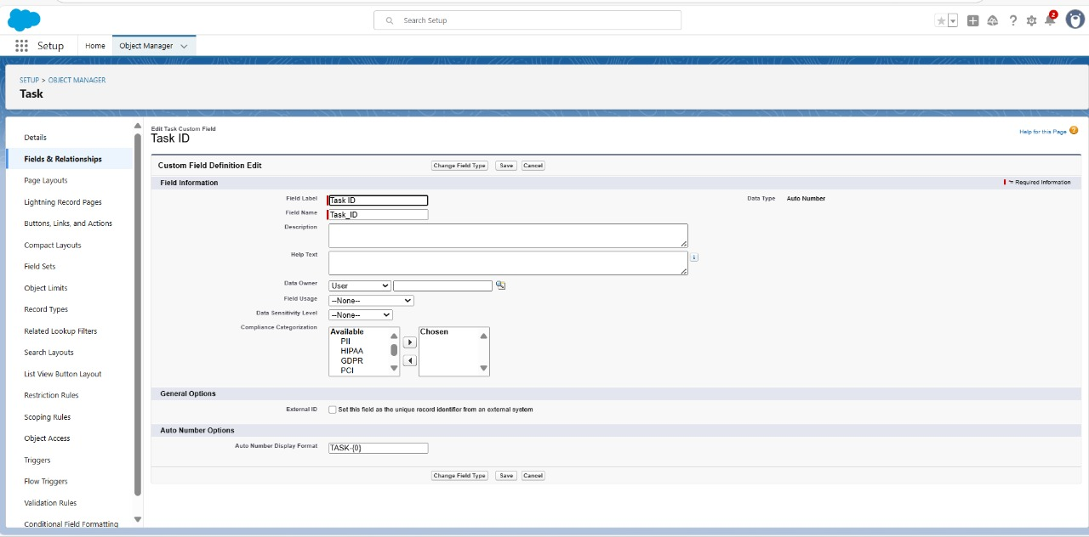

To create Date in Task object:

1. Go to setup >> click on Object Manager >> type object name (Task) in search bar >> click on the object.
2. Now click on “Fields & Relationships” >> New
3. Select Data type as a “Date” and Click on Next
4. Fill the Above as following:
   * Field Label: Date
   * Field Name: Date
   * Click on required check box
   * Click on Next >> Next >> Save and new.

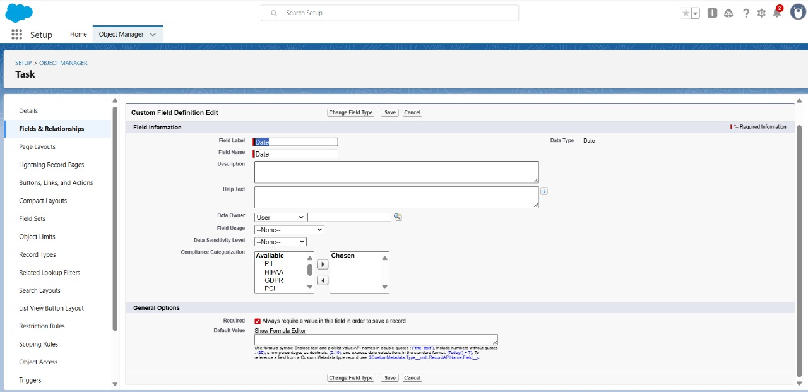

To create Food Category fields in an object:

1. Go to setup >> click on Object Manager >> type object name (Task) in search bar >> click on the object.
2. Now click on “Fields & Relationships” >> New
3. Select Data type as a “Picklist (Multi-Select)” and Click on Next
4. Fill the Above as following:
   * Field Label: Food Category
   * Field Name: Food Category
   * Enter values, with each value separated by a new line:

Veg

Non-Veg

Salad Snack

* + Click on required check box
  + Click on Next >> Next >> Save and new.

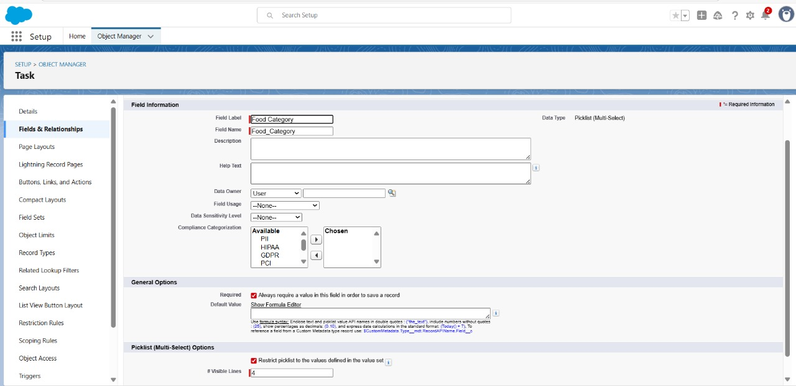

To create Number of People Served in Task object:

1. Go to setup >> click on Object Manager >> type object name(Task) in search bar >> click on the object.
2. Now click on “Fields & Relationships” >> New
3. Select Data type as a “Number” and Click on Next
4. Fill the Above as following:
   * Field Label : Number of People Served
   * Field Name : Number_of_People_Served
   * Click on required check box
   * Click on Next >> Next >> Save and new.

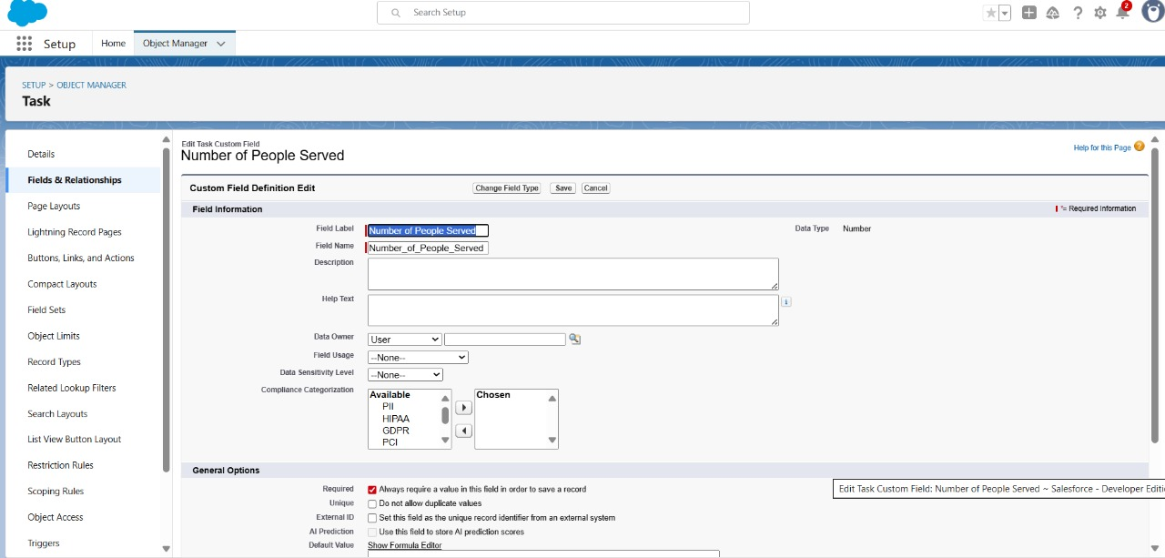

To create Name of the Person in Task object:

1. Go to setup >> click on Object Manager >> type object name(Task) in search bar >> click on the object.
2. Now click on “Fields & Relationships” >> New
3. Select Data type as a “Text” and Click on Next
4. Fill the Above as following:
   * Field Label : Name of the Person
   * Field Name : Name_of_the_Person
   * Click on Next >> Next >> Save and new.

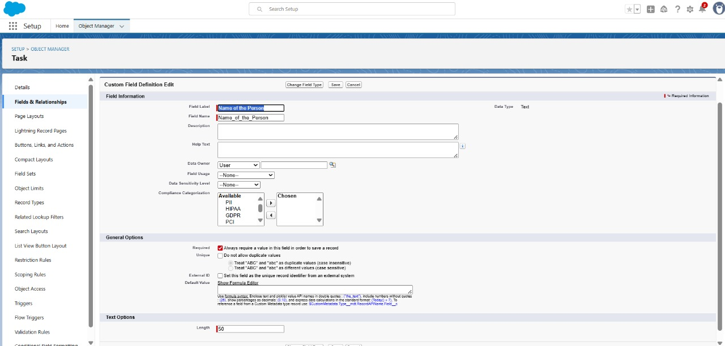

To create Phone fields in Task object:

1. Go to setup>> click on Object Manager >> type object name(Task) in search bar >> click on the object.
2. Now click on “Fields & Relationships” >> New
3. Select Data type as a “Phone” and Click on Next
4. Fill the Above as following:
   * Field Label : Phone
   * Field Name : Phone
   * Click on Next >> Next>> Save and new.

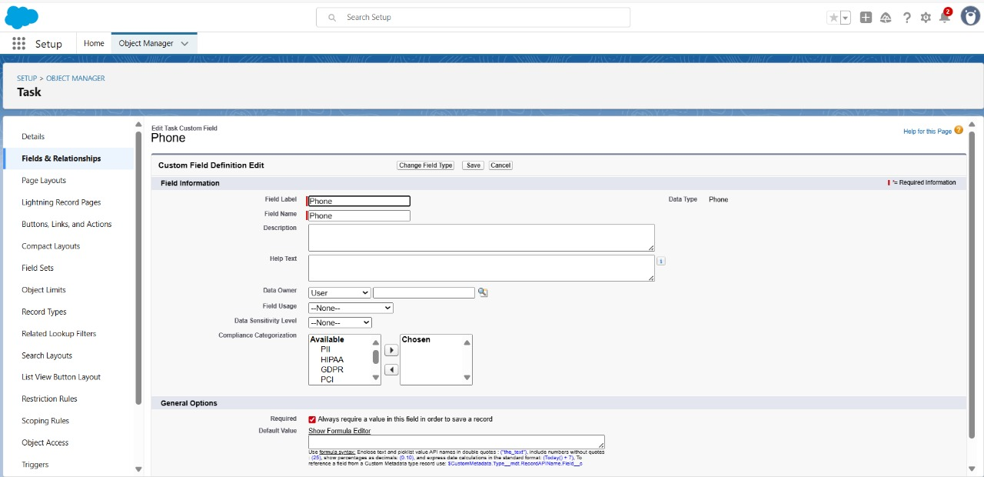

To create Rating in Task object:

Go to setup >> click on Object Manager >> type object name(Task) in search bar >> click on the object.

1. Now click on “Fields & Relationships” >> New
2. Select Data type as a “Pick List” and Click on Next
3. Fill the Above as following:
   * Field Label : Rating
   * Field Name : Rating
   * Enter values, with each value separated by a new line :

1

2

3

4

5

* + Click on Next >> Next >> Save and new.

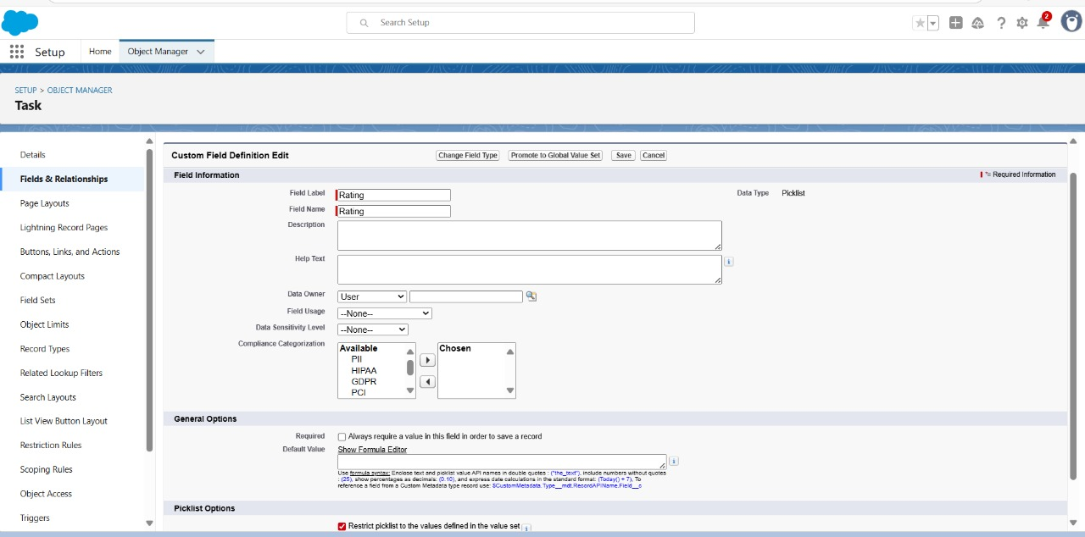

To create another fields in an object:

1. Go to setup >> click on Object Manager >> type object name(Task) in search bar >> click on the object.
2. Now click on “Fields & Relationships” >> New
3. Select Data type as a “Long Text Area” and Click on Next
4. Fill the Above as following:
   * Field Label : Feedback
   * Field Name : Feedback
   * Click on Next >> Next >> Save and new.

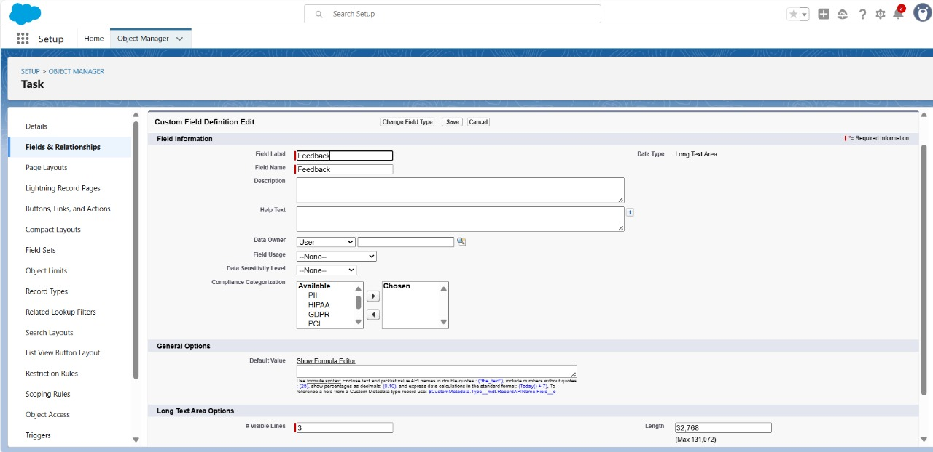

# Creation of fields for the Volunteer object

To create Volunteer ID in Volunteer object:

1. Go to setup >> click on Object Manager >> type object name(Volunteer) in search bar >> click on the object.
2. Now click on “Fields & Relationships” >> New
3. Select Data type as a “Auto Number” and Click on Next
4. Fill the Above as following:
   1. Field Label : Volunteer ID
   2. Field Name : gets auto generated
   3. Click on required check box
   4. Click on Next >> Next >> Save and new.

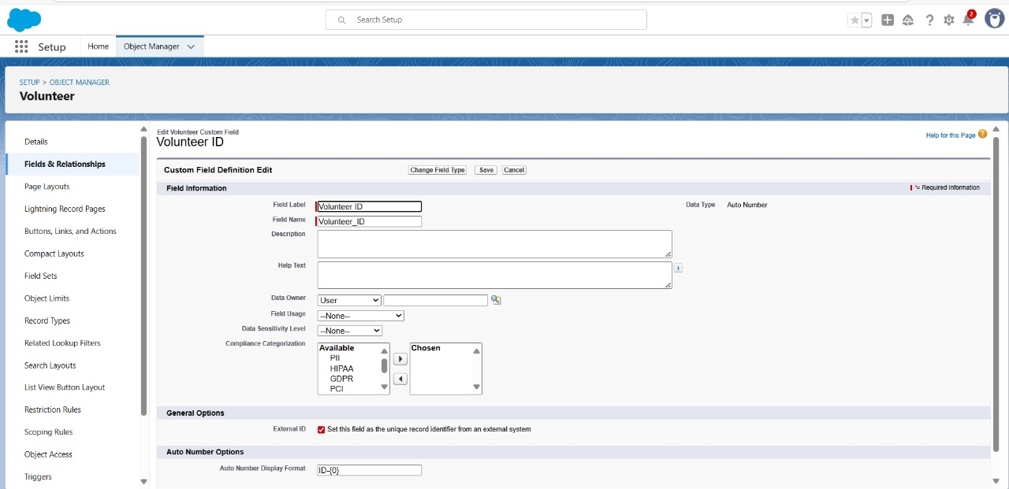

To create Gender in Volunteer object:

1. Go to setup >> click on Object Manager >> type object name(Volunteer) in search bar >> click on the object.
2. Now click on “Fields & Relationships” >> New
3. Select Data type as a “Picklist” and Click on Next
4. Fill the Above as following:
   * Field Label : Gender
   * Field Name : Gender
   * Enter values, with each value separated by a new line :

Female

Male

* + Click on Next >> Next >> Save and new.

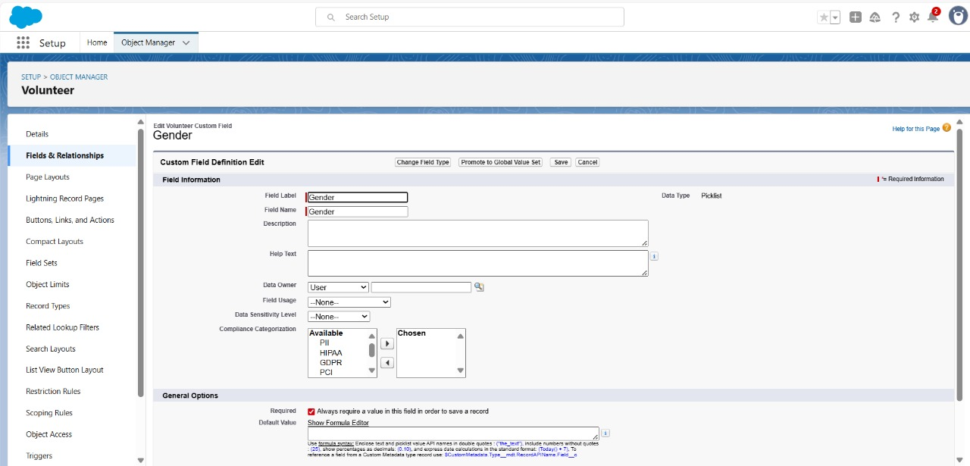

To create Available On in Volunteer object:

1. Go to setup >> click on Object Manager >> type object name(Volunteer) in search bar >> click on the object.
2. Now click on “Fields & Relationships” >> New
3. Select Data type as a “Date” and Click on Next
4. Fill the Above as following:
   * Field Label : Available On
   * Field Name : Available On
   * Click on required check box
   * Click on Next >> Next >> Save and new.

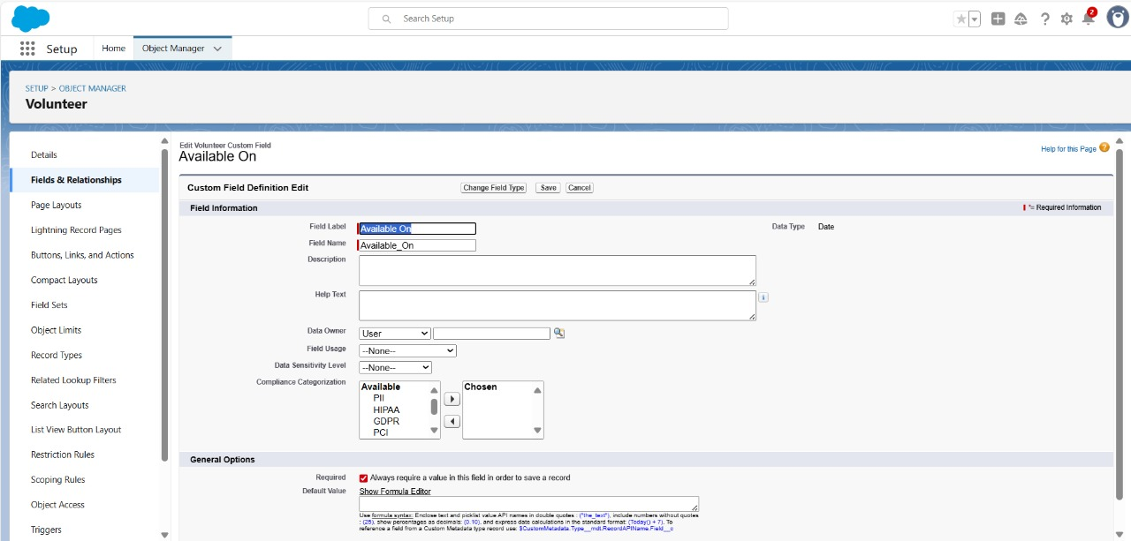

To create Age in Volunteer object:

1. Go to setup >> click on Object Manager >> type object name(Volunteer) in search bar >> click on the object.
2. Now click on “Fields & Relationships” >> New
3. Select Data type as a “Number” and Click on Next
4. Fill the Above as following:
   * Field Label : Age
   * Field Name : Age
   * Click on required check box
   * Click on Next >> Next>> Save and new.

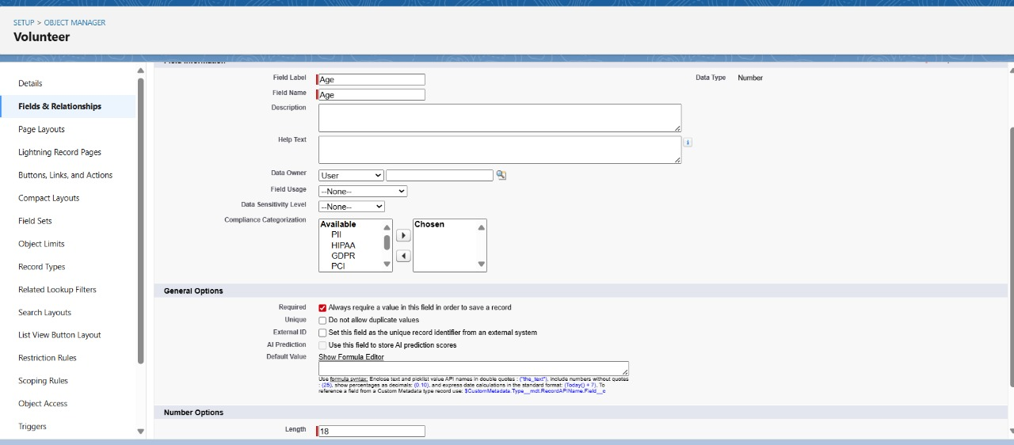

To create Email in Volunteer object:

1. Go to setup >> click on Object Manager >> type object name(Volunteer) in search bar >> click on the object.
2. Now click on “Fields & Relationships” >> New
3. Select Data type as a “Email” and Click on Next
4. Fill the Above as following:
   * Field Label : Email
   * Field Name : Email
   * Click on required check box
   * Click on Next>> Next >> Save and new.

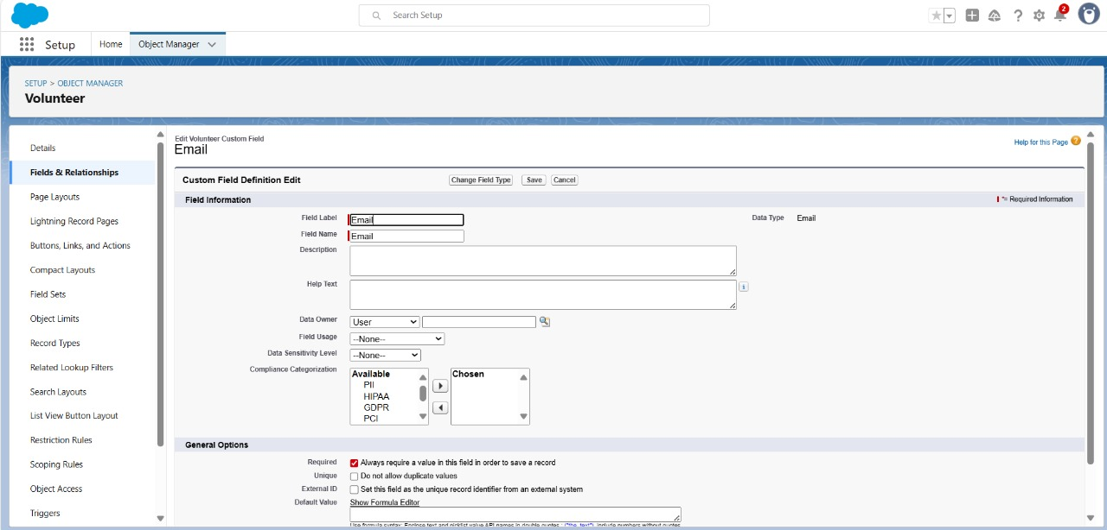

To create Contact Number in Volunteer object:

1. Go to setup >> click on Object Manager >> type object name(Volunteer) in search bar >> click on the object.
2. Now click on “Fields & Relationships” >> New
3. Select Data type as a “Number” and Click on Next
4. Fill the Above as following:
   * Field Label : Contact Number
   * Field Name : Contact_Number
   * Click on required check box
   * Click on Next >> Next >> Save and new.

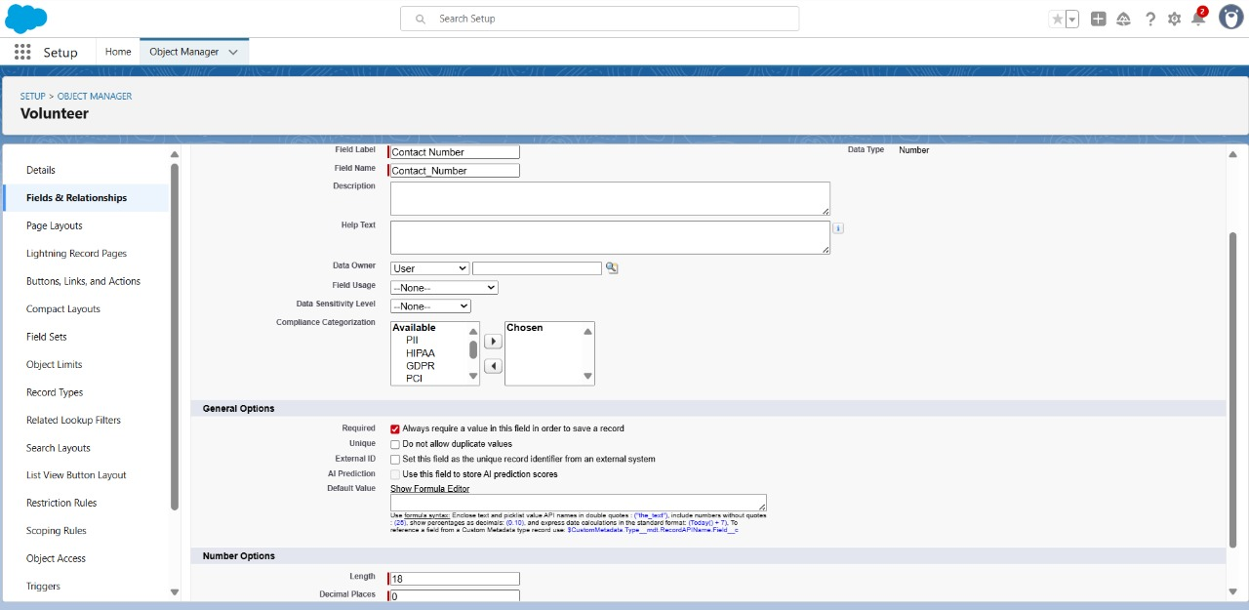

To create Address in Volunteer object:

1. Go to setup >> click on Object Manager >> type object name(Volunteer) in search bar >> click on the object.
2. Now click on “Fields & Relationships” >> New
3. Select Data type as a “Text Area (Long)” and Click on Next
4. Fill the Above as following:
   * + Field Label : Address
     + Field Name : Address
     + Click on Next >> Next >> Save and new.

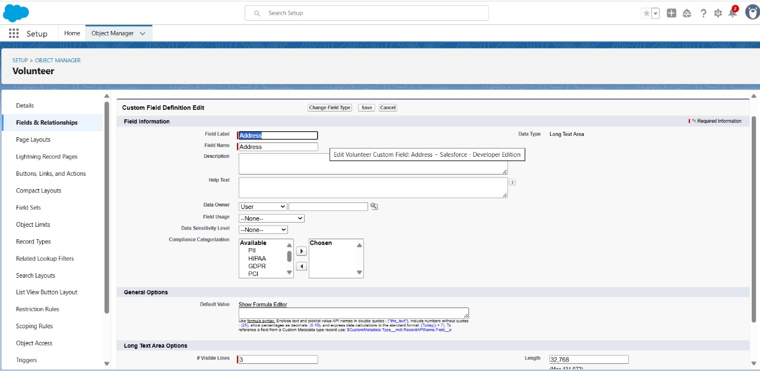

To create Date of Birth in Volunteer object:

1. Go to setup >> click on Object Manager >> type object name(Volunteer) in search bar >> click on the object.
2. Now click on “Fields & Relationships” >> New
3. Select Data type as a “Date” and Click on Next
4. Fill the Above as following:
   * + Field Label : Date of Birth
     + Field Name : Date_of_Birth
     + Click on Next >> Next >> Save and new.

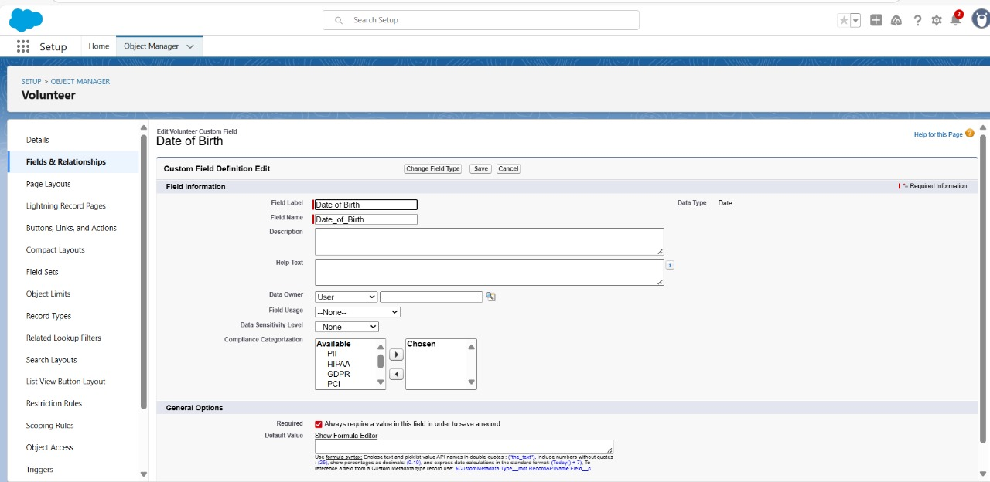

# Creation of fields for the Execution Details object

1. Go to setup >> click on Object Manager >> type object name(Volunteer) in search bar >> click on the object.
2. Now click on “Fields & Relationships” >> New
3. Select Data type as a “Auto Number” and Click on Next
4. Fill the Above as following:
   * + Field Label : Execution ID
     + Field Name : gets auto generated
     + Click on required check box
     + Click on Next >> Next >> Save and new

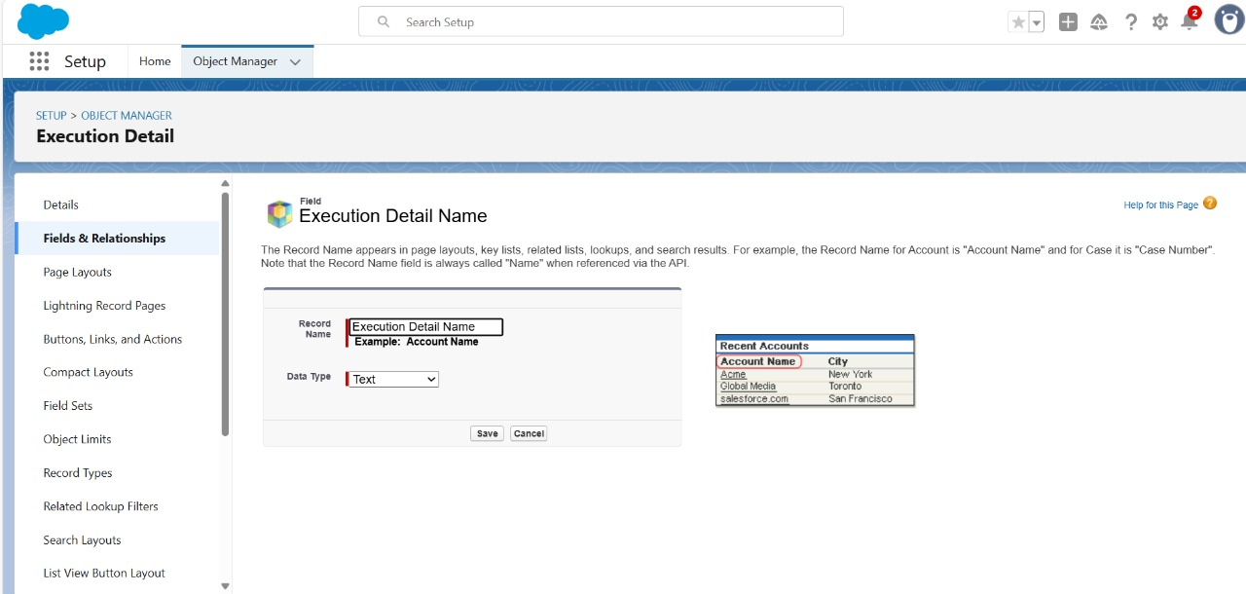

# Create Flow to create a record in Venue object

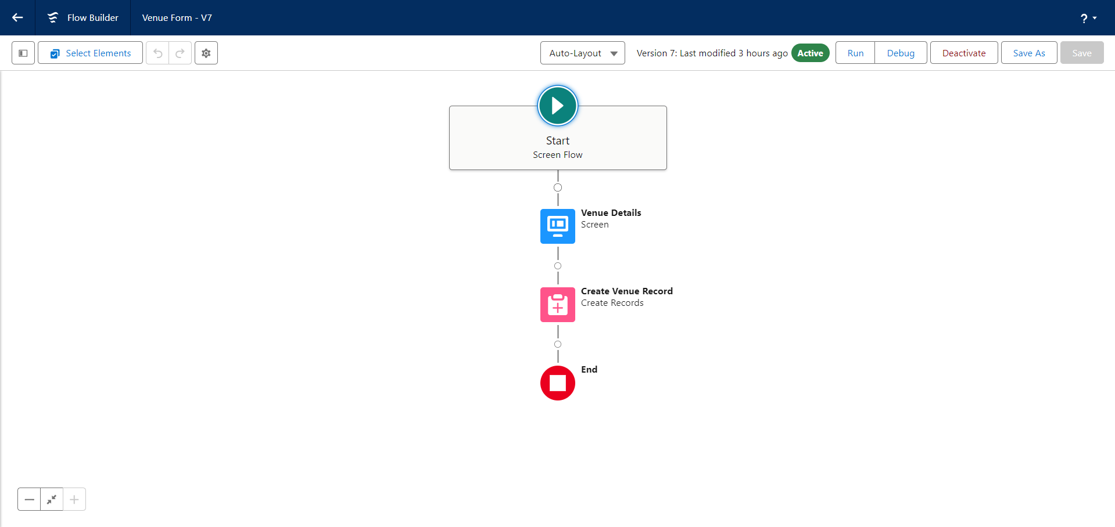the flow should look like this----

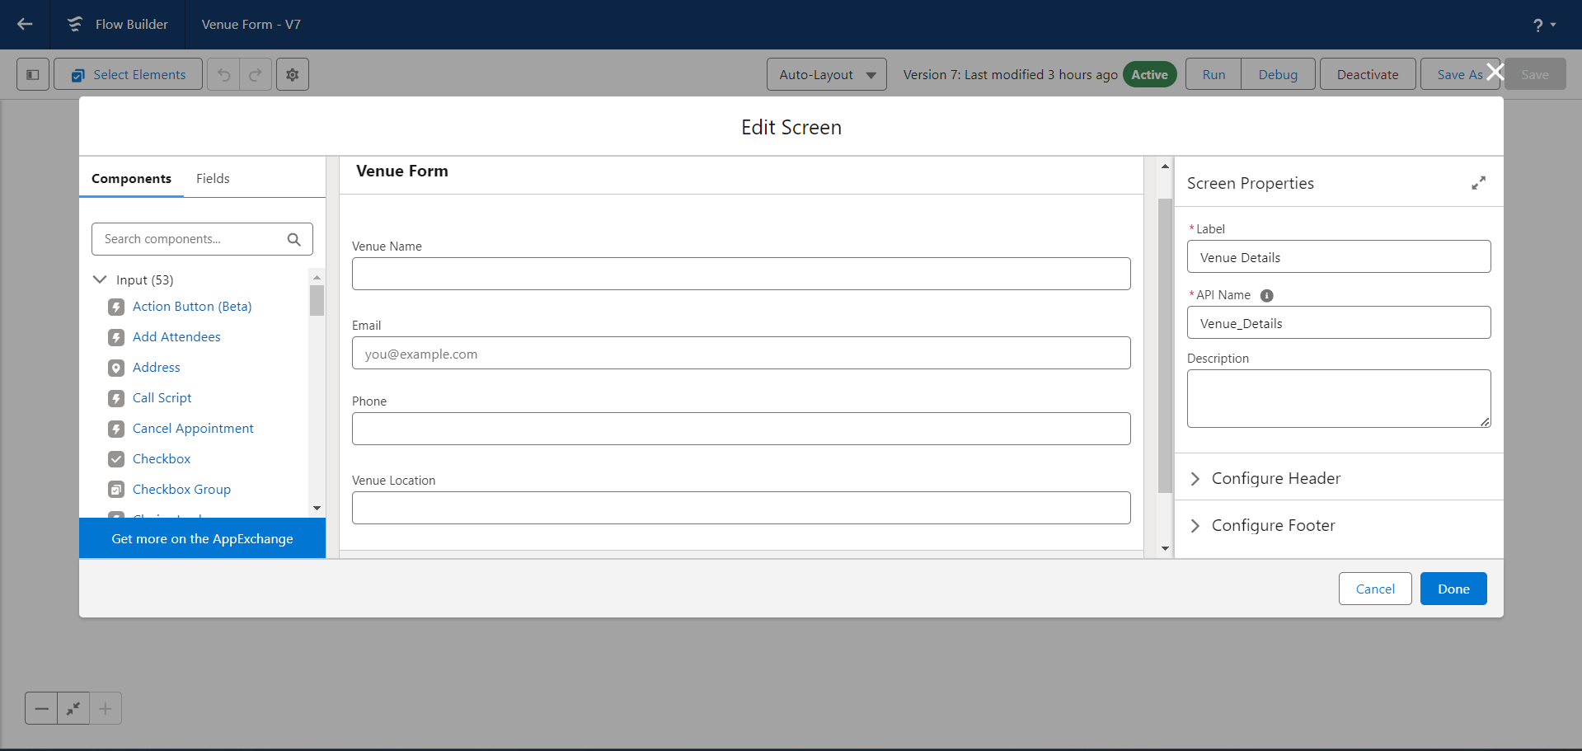

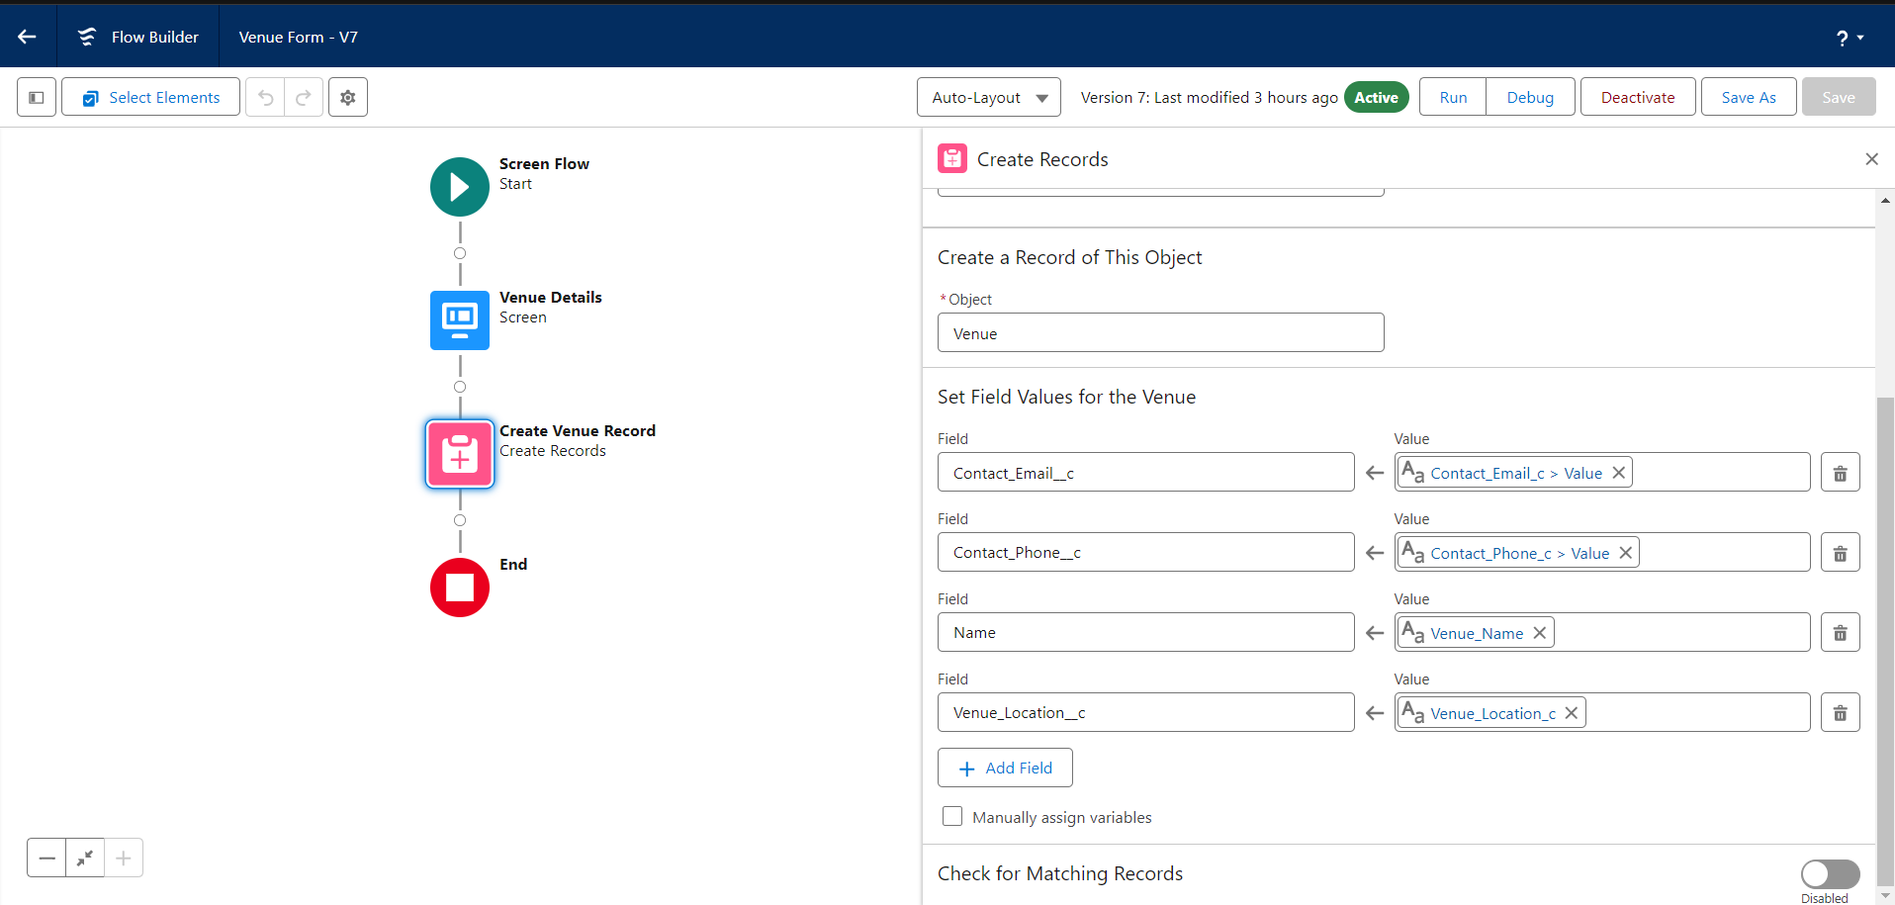

# Create a Trigger

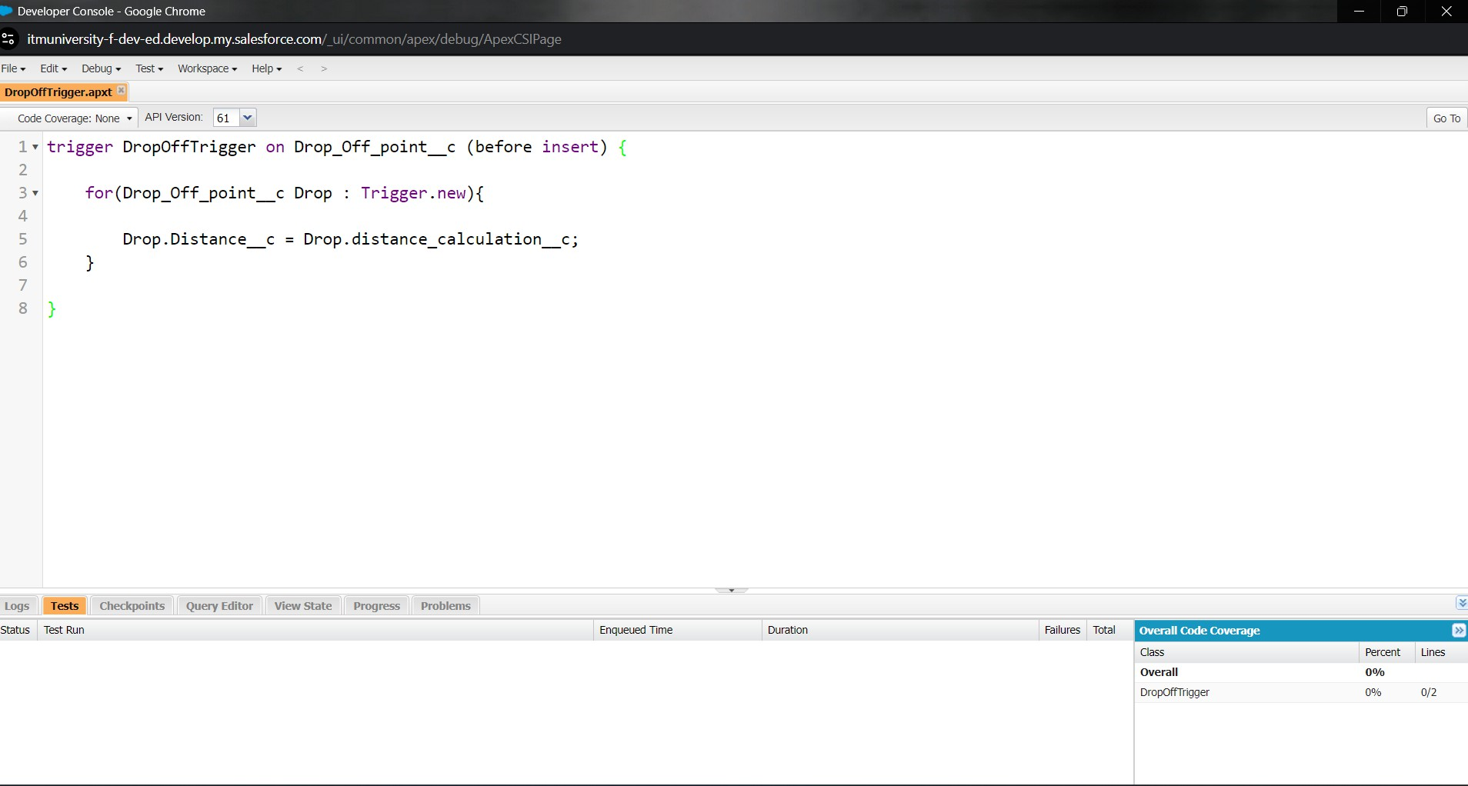

the code should look like this the trigger has created.

# Creation of Users and profile

here we have to create a NGOs profile and under this profile we have to cretae a users that are going to be the NGOs foundations

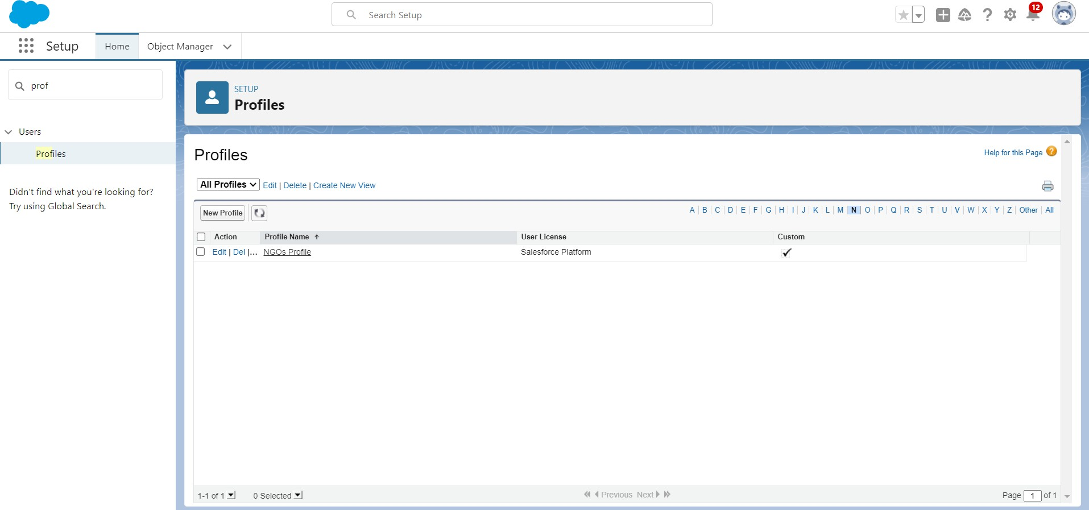

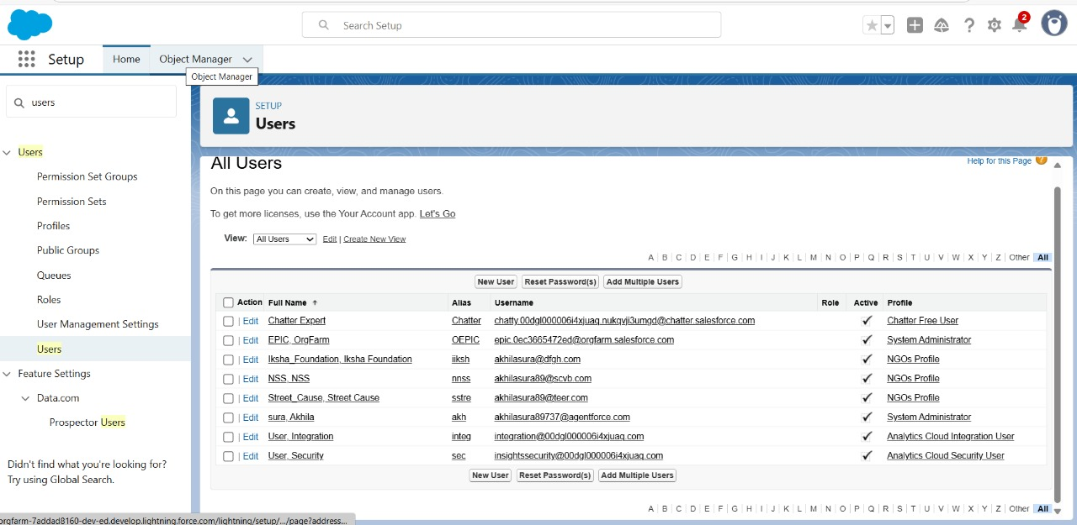

1. Creation of Public Group 1,2,3

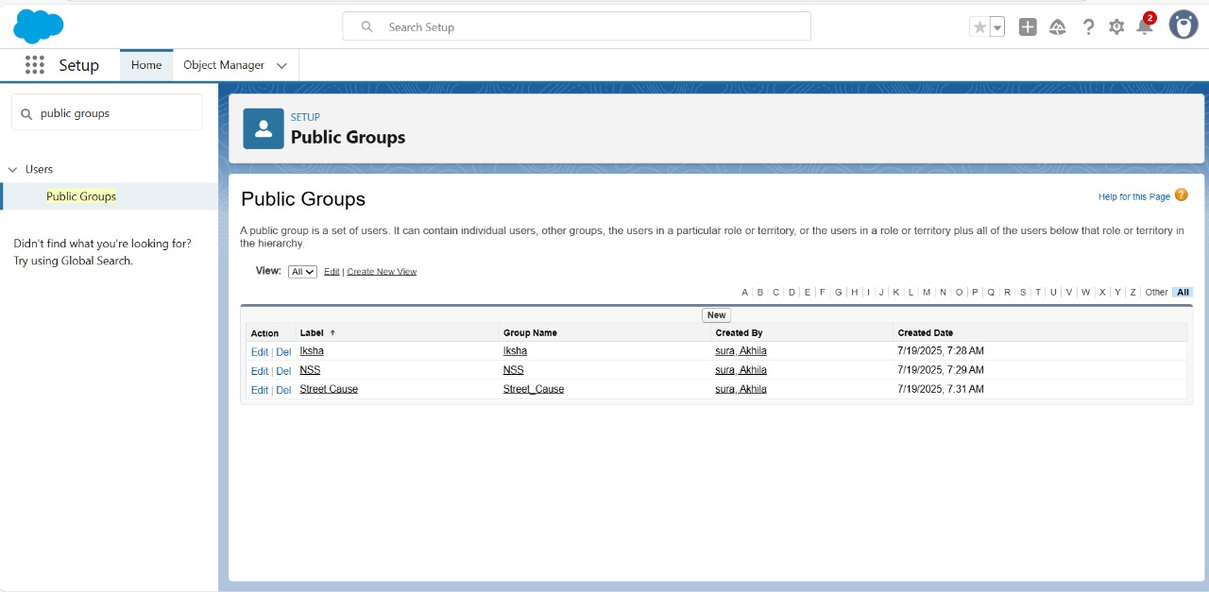

Creation of Report on Venue with Drop-Off with Volunteer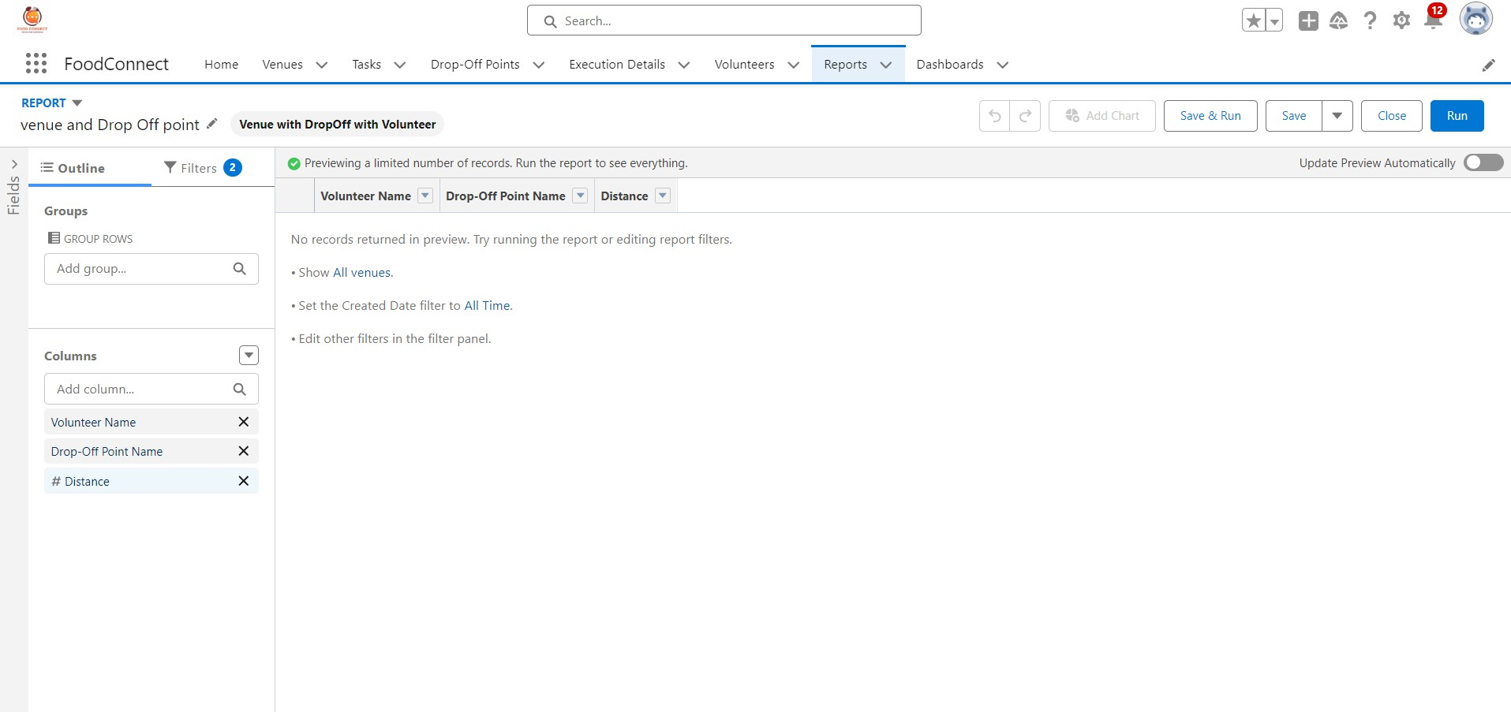

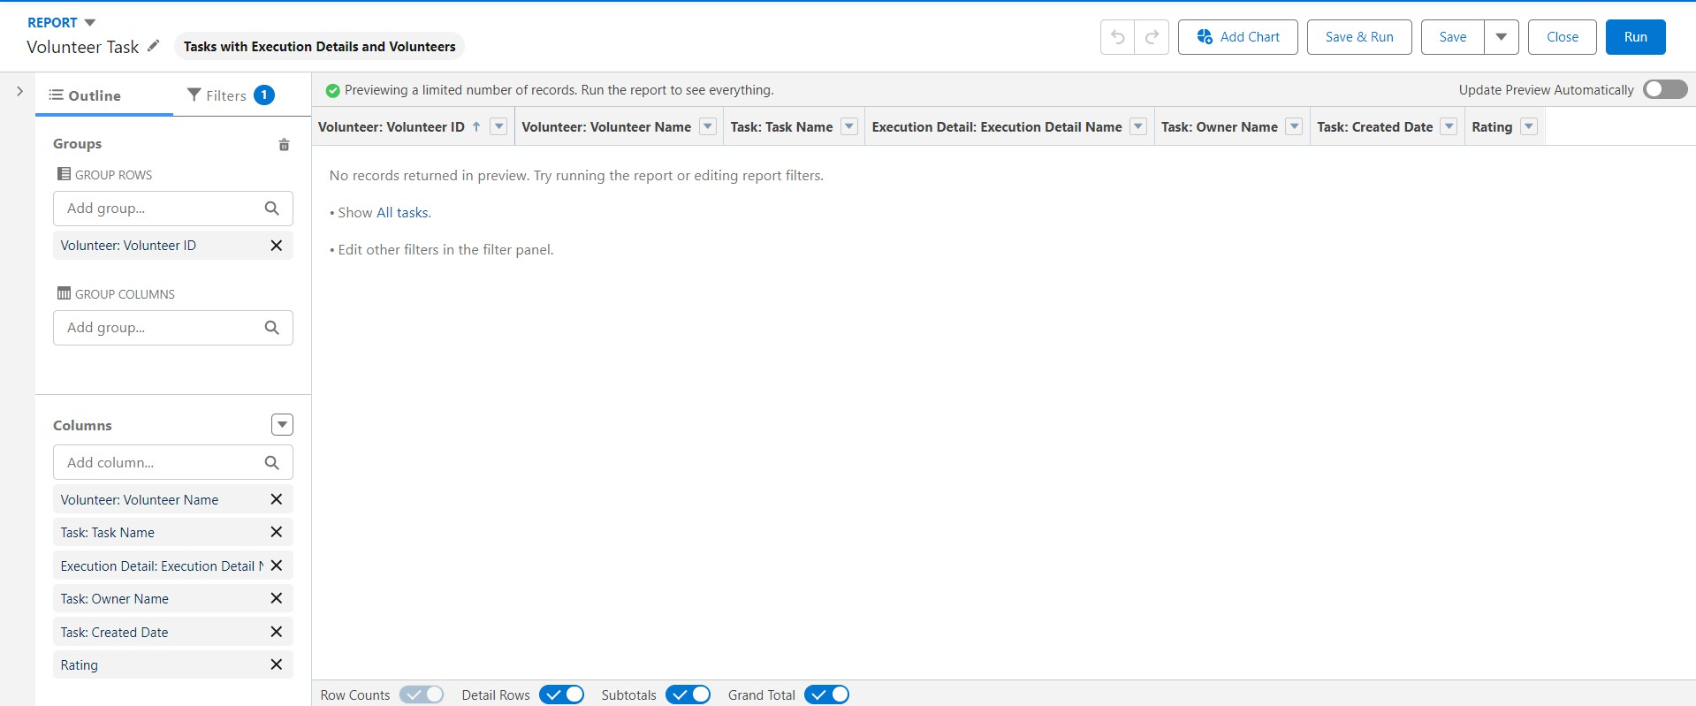Creation of Report on Volunteers with Execution Details and Tasks

1. Dashboard

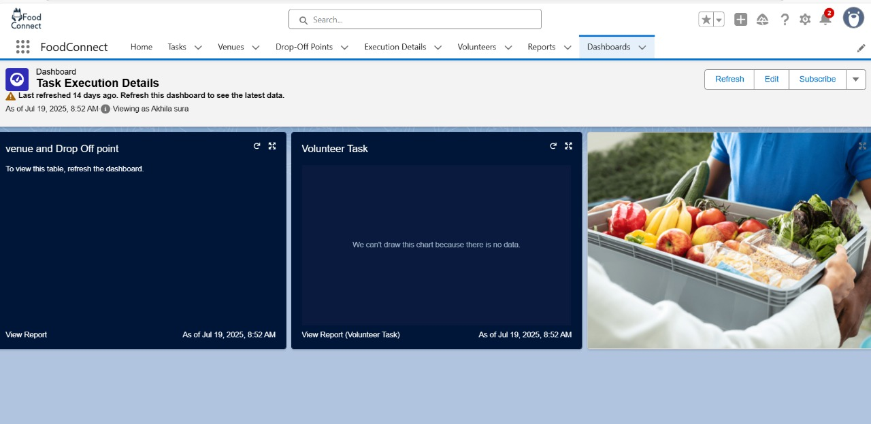

1. Creation of sharing rules

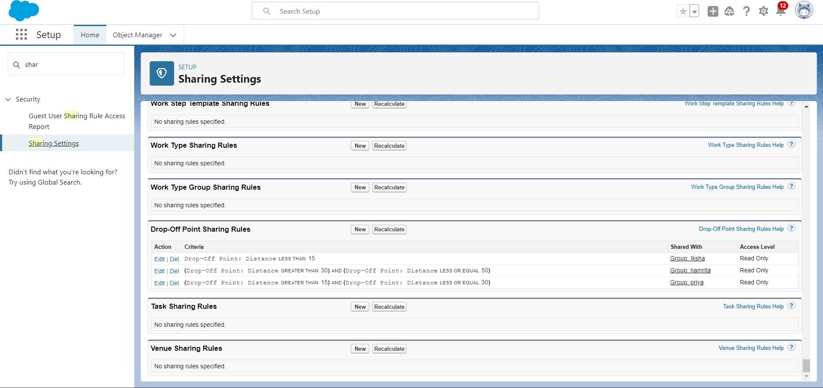

1. Creation of Home Page

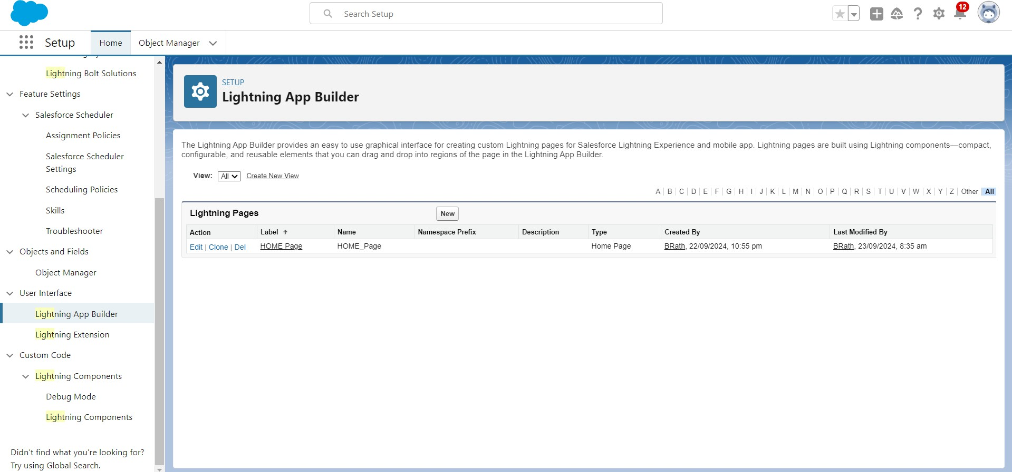

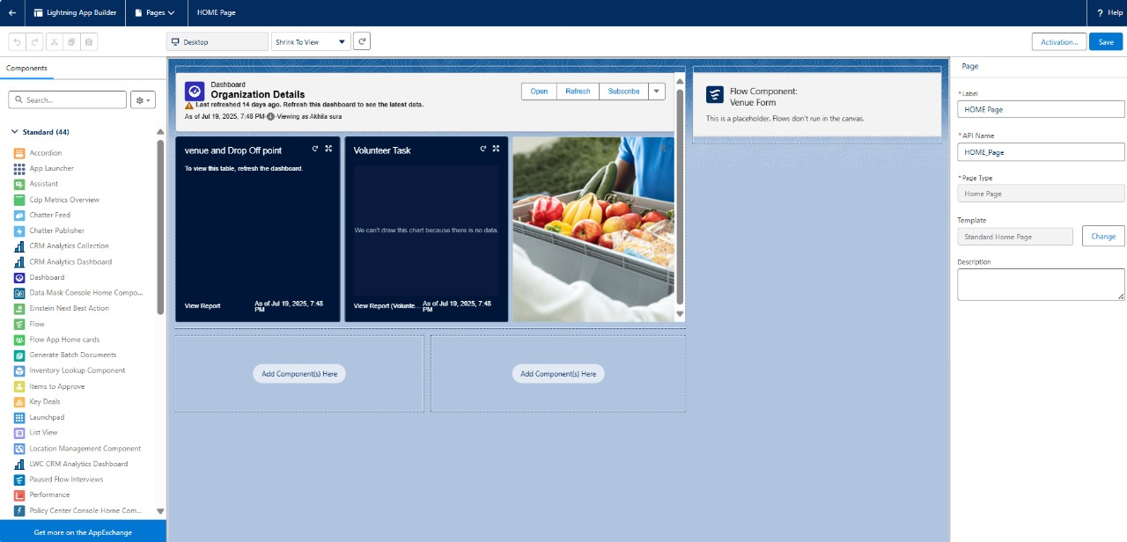

## OUTPUT SCREENSHOTS

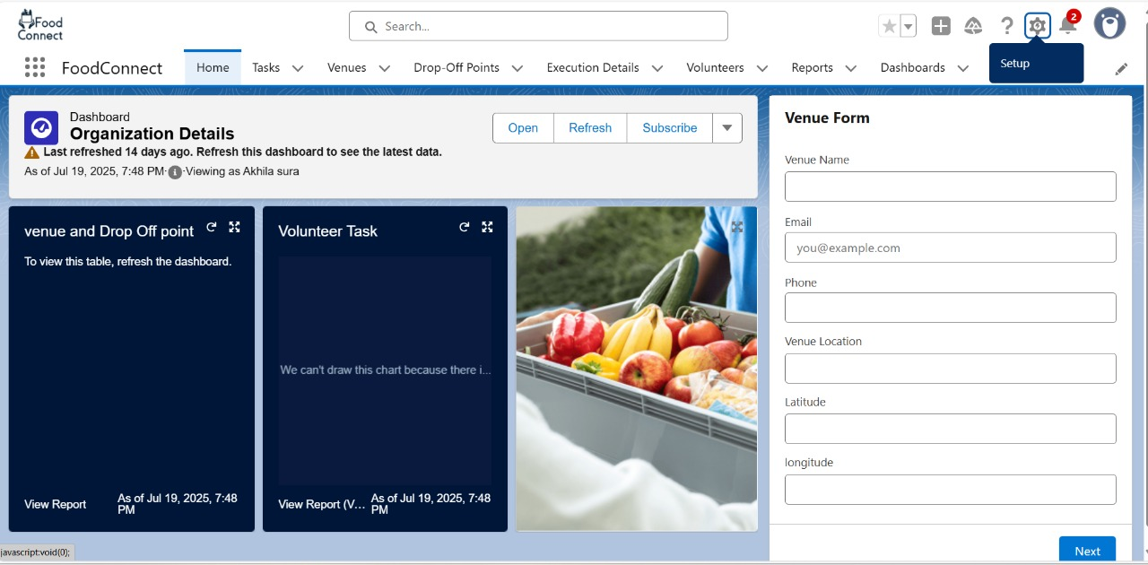

THE FINAL OUTPUT OF THE APP SHOULD LOOK LIKE THIS AFTER FOLLOWING ALL THE STEPS CORECTLY AS YOU CAN SE MY OUTPUT LOOKS CORRECT AS THE OUTPUT SHOULD BE LIKE THIS

# Conclusion

By utilizing the capabilities of the Salesforce platform, the initiative built an efficient and transparent system for managing excess food donations. It ensured smooth coordination with volunteers and prompt delivery to recipients, helping to combat food insecurity and optimize resource use.  
**Food Connect** is designed to close the gap between surplus food and communities in need by automating and simplifying the donation process through Salesforce. The project highlights how Salesforce’s adaptable features can support non-profit operations and drive meaningful social impact through technology.